**PANDIT DEENDAYAL ENERGY UNIVERSITY**

**SCHOOL OF TECHNOLOGY**



**Machine Learning Lab**

**20CP401P**

**LAB MANUAL**

**B.Tech. (Computer Science and Engineering)**

**Semester 7**

|  |  |
| --- | --- |
| **Submitted To:** | **Submitted By:** |
| Dr. Archana Nigam | HARSH SHAH |
|  | 21BCP359 |
|  | G11 Batch |

**INDEX**

|  |  |  |
| --- | --- | --- |
| **Exp. No.** | **Assignment Title** | **Page No.** |
| **1** | Discuss and analyse different data visualization tools. | 1 |
| **2** | Measurements of electric power consumption in one household with a one-minute sampling rate over a period of almost 4 years. Different electrical quantities and some sub-metering values are available. | 12 |
| **3** | Implement simple and multi-linear regression to predict profits for a food truck. Compare the performance of the model on linear and multi-linear regression. | 29 |
| **4** | Implement the non-parametric Locally Weighted Regression algorithm in order to fit data points. Select appropriate data set for your experiment and draw graphs | 34 |
| **5** | For a given set of training data examples stored in a .CSV file, implement and demonstrate various feature selection algorithms and compare the performance of the algorithms. | 38 |
| **6** | Apply Different Machine Learning Approaches for the Classification Task. Compare the Performance of Different ML Approaches in Terms of Accuracy, Precision, and Recall. | 44 |
| **7** | Train a Machine Learning Classifier on an Imbalanced Dataset. Then Balance the Dataset Using Oversampling Techniques. Compare the Model Performance Before and After Oversampling. | 49 |
| **8** | Apply Different Feature Selection Approaches for the Classification/Regression Task. Compare the Performance of Different Feature Selection Approaches. | 53 |
| **9** | Write a Program to Demonstrate the Working of the Decision Tree-Based CART Algorithm. Build the Decision Tree and Classify a New Sample Using a Suitable Dataset. Compare the Performance with That of ID3, C4.5, and CART in Terms of Accuracy, Recall, Precision, and Sensitivity. | 58 |
| **10** | Implement Dimensionality reduction using Principal Component Analysis (PCA) method. | 65 |

LAB ASSIGNMENT 1

|  |  |  |  |
| --- | --- | --- | --- |
| **Name:** | Harsh Shah | **Roll No.:** | 21BCP359 |
| **Division:** | 6 | **Batch:** | G11 |
| **Aim:** | Discuss and analyze different data visualization tools. | | |

**Objective**

The objective of this lab assignment is to explore and analyse various data visualization tools used for representing and understanding complex datasets. Through this assignment, you will gain insights into the strengths, weaknesses, and practical applications of different visualization tools.

Dataset Used: [U.S. International Air Traffic data (1990-2020) - Kaggle](https://www.kaggle.com/datasets/parulpandey/us-international-air-traffic-data)

**Introduction to Data Visualization**

Data visualization is the graphical representation of information and data. By using visual elements like charts, graphs, and maps, data visualization tools provide an accessible way to see and understand trends, outliers, and patterns in data. It’s an essential skill in the data analysis process, helping to make complex data more understandable, insightful, and actionable.

Key Types of Data Visualizations:

* **Charts**: Including bar charts, line charts, pie charts, and histograms, these are used to compare different categories or show changes over time.
* **Graphs**: Such as scatter plots and area graphs, these help in understanding relationships between variables.
* **Maps**: Geographic data can be visualized using maps to highlight spatial patterns and distributions.
* **Infographics**: These combine various visualization elements to tell a story or provide a comprehensive overview of data.
* **Dashboards**: Interactive platforms that allow users to manipulate data and visuals to explore different perspectives and insights.

**Data Visualisation Tools**

* **Microsoft Excel**: A widely used tool that offers basic to advanced charting and graphing capabilities.
* **Python Libraries**: Libraries like Matplotlib, Seaborn, and Plotly are popular among data scientists for creating a wide range of static, animated, and interactive visualizations.
* **Tableau**: A powerful tool for creating interactive and shareable dashboards.
* **Power BI**: A business analytics service by Microsoft that provides interactive visualizations and business intelligence capabilities.
* **Google Data Studio**: A free tool that transforms your data into informative, easy-to-read, and shareable dashboards and reports.
* **R/JS Libraries**: Libraries like ggplot2(R), plotly(R), D3.js(JS), plotly(JS) are popular among for creating a wide range of static, animated, and interactive visualizations.

**Brief Overview of Tool Capabilities and Features**

1. **Matplotlib (Python)**

* Matplotlib is a versatile plotting library in Python that produces publication-quality figures in a variety of formats and interactive environments.
* Wide Range of Plots: Supports line plots, scatter plots, bar charts, histograms, pie charts, error bars, and more.
* Subplots and Axes: Allows creation of complex, multi-plot layouts.
* Use Cases: Scientific Research, Financial Analysis

1. **Seaborn (Python)**

* Seaborn is a statistical data visualization library based on Matplotlib, providing a high-level interface for drawing attractive and informative statistical graphics.
* Complex Plots Simplified: Simplifies the creation of complex visualizations such as heatmaps, time series, violin plots, and pair plots.
* Statistical Plotting: Integrates with pandas Data Frames and supports statistical aggregation and plotting.
* Use Cases: Exploratory Data Analysis (EDA), Statistical Data Visualization

1. **Power BI**

* Power BI is a business analytics service by Microsoft that delivers insights to enable fast, informed decisions.
* Interactive Dashboards: Allows creation of interactive and shareable dashboards.
* Data Connectivity: Connects to a wide variety of data sources, including databases, web services, and Excel spreadsheets.
* Data Modelling: Offers robust data modelling and transformation capabilities.
* Real-Time Analytics: Supports real-time data visualization and streaming analytics.
* Use Cases: Business Intelligence and Reporting, Real-Time Data Monitoring

1. **Plotly (Python)**

* Plotly is an interactive graphing library for Python, known for its high-quality and interactive plots.
* Interactive Graphs: Produces interactive plots that can be embedded in web applications or dashboards.
* Dash by Plotly: Integrated with Dash, a framework for building interactive web applications with Python.
* Ease of Use: User-friendly API and integration with pandas for quick and easy plotting.
* Cross-Platform: Plots can be viewed in Jupyter Notebooks, standalone HTML files, or web applications.
* Use Cases: Interactive Web Applications, 3D Data Visualization

**Code Snippets**

1. **Using Seaborn and Matplotlib**

sns.countplot(*x*='type',*data*=full_data, *color*="deepskyblue")

plt.title('Distrubtion Of Type',*fontsize*=20 , *color*="black")

plt.grid(True)

plt.xticks(*rotation*=60)

plt.show()

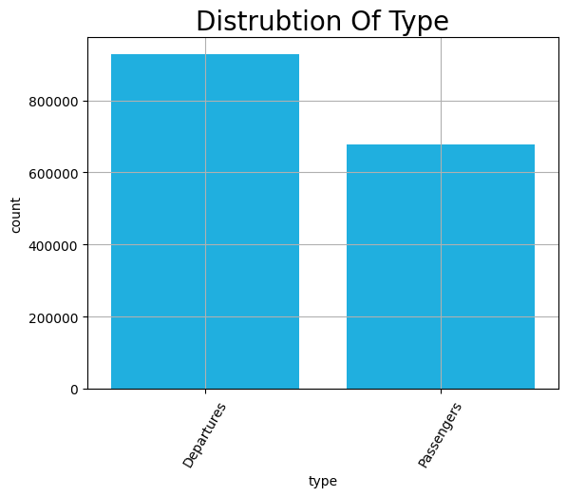

sns.countplot(*x*='carriergroup',*data*=full_data, *color*="orange")

plt.title('Distrubtion Of CarrierGroup',*fontsize*=20)

plt.grid(True)

plt.xticks(*rotation*=45)

plt.show()

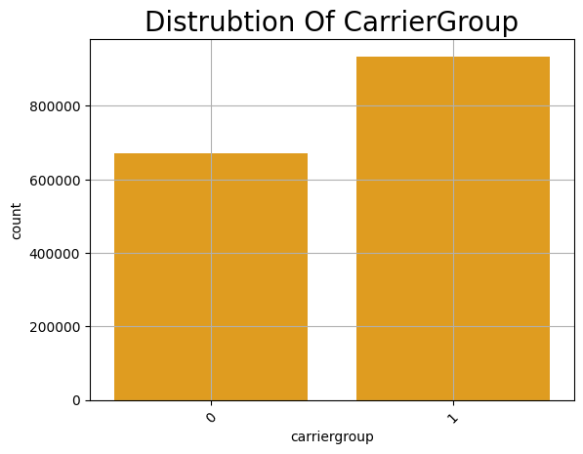

plt.figure(*figsize*=(10, 6))

sns.relplot(*x*='Year', *y*='Total', *data*=full_data ,  *color*='deepskyblue')

plt.xlabel('Year')

plt.ylabel('Total Flights')

plt.title('Total Flights by Year')

plt.xticks(*rotation*=45)

plt.show()

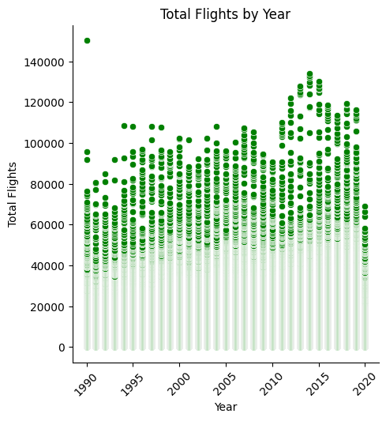

plt.figure(*figsize*=(10, 6))

sns.relplot(*x*='Year', *y*='Total',*hue*='carriergroup',*data*=full_data, *color*='green')

plt.xlabel('Year')

plt.ylabel('Total Flights')

plt.title('Total Flights by Year')

plt.grid(True)

plt.xticks(*rotation*=45)

plt.show()

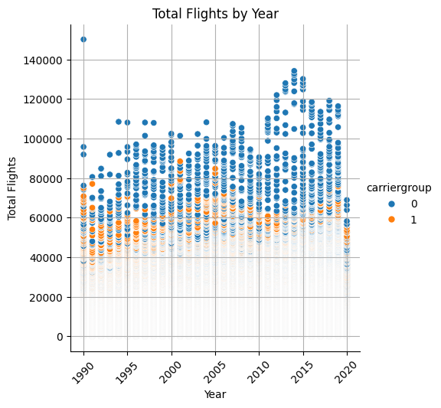

plt.figure(*figsize*=(10, 6))

sns.barplot(*x*='Year', *y*='Total',*hue*='carriergroup',*data*=full_data)

plt.xlabel('Year')

plt.ylabel('Total Flights')

plt.title('Total Flights by Year')

plt.grid(True)

plt.xticks(*rotation*=45)

plt.show()

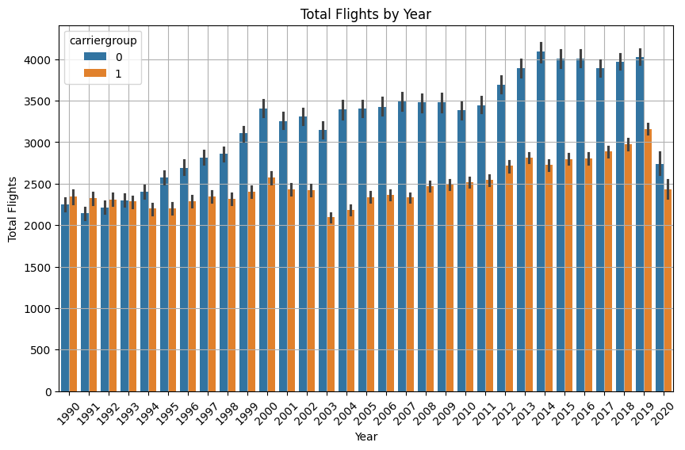

plt.figure(*figsize*=(10, 6))

sns.barplot(*x*='Year', *y*='Total',*hue*='type',*data*=full_data, *color*='lightblue' )

plt.xlabel('Year')

plt.ylabel('Total Flights')

plt.title('Total Flights by Year')

plt.xticks(*rotation*=45)

plt.grid(True)

plt.show()

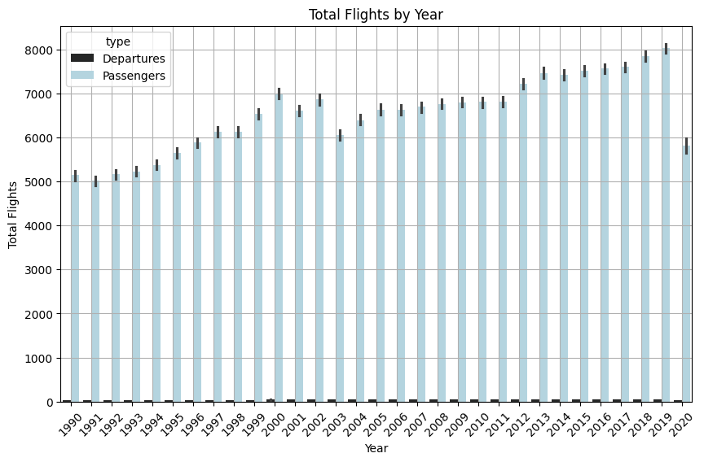

plt.figure(*figsize*=(10, 6))

sns.lineplot(*x*='Year', *y*='Scheduled', *data*=full_data, *label*='Scheduled Flights')

sns.lineplot(*x*='Year', *y*='Charter', *data*=full_data, *label*='Chartered Flights')

sns.color_palette("flare", *as_cmap*=True)

plt.title('Total Flights per Year')

plt.xlabel('Year')

plt.ylabel('Total Flights (in Million)')

plt.xticks(*rotation*=45)

plt.grid(True)

plt.legend()

plt.show()

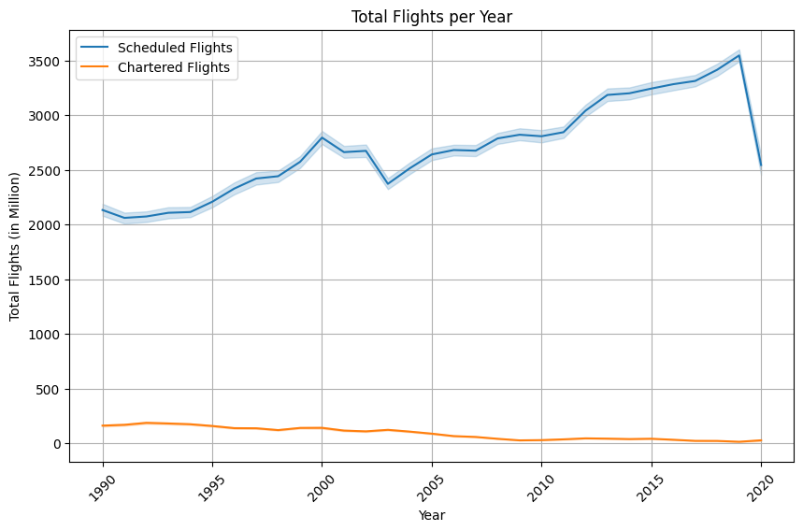

plt.figure(*figsize*=(10,15))

x=1

for i,j in zip(['usg_wac','fg_wac','Charter','Total'],['red','green','black','yellow']):

  plt.subplot(2,2,x)

  sns.boxplot(*x*=i,*data*=full_data,*color*=j)

  plt.ylabel('Value',*fontsize*=20)

  plt.title(*f*'BoxPlot For {i}',*fontsize*=20)

  plt.xticks(*rotation*=45)

  x+=1

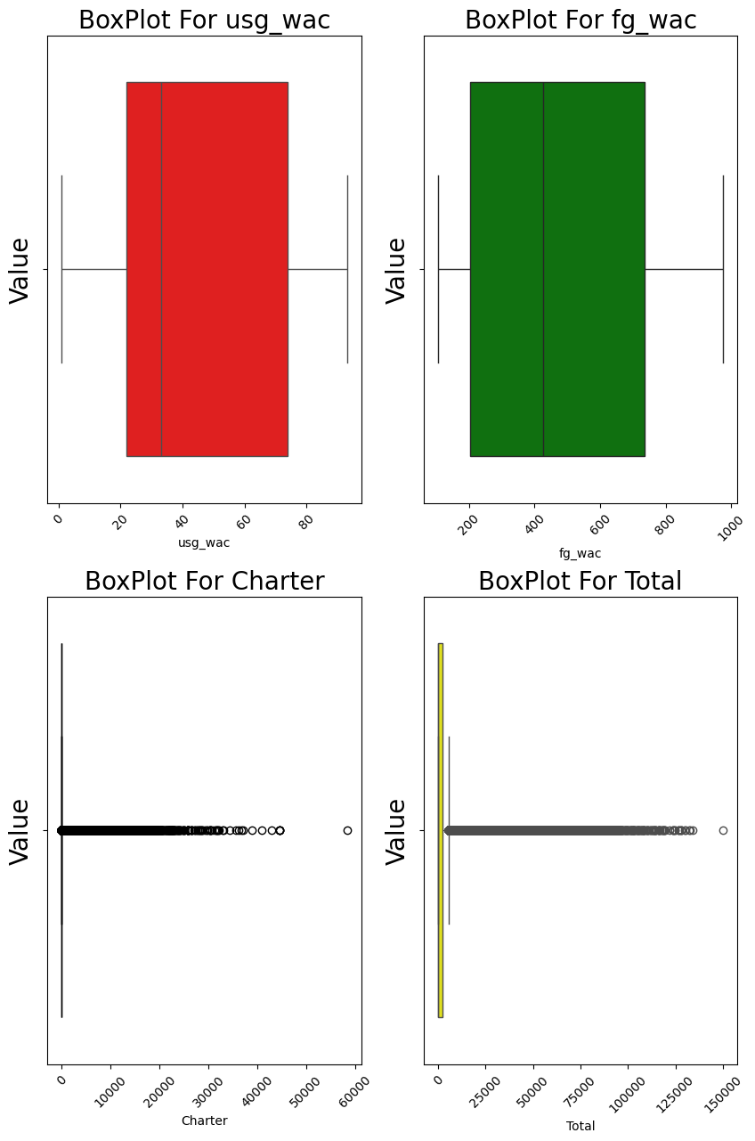

numerical_data = full_data.select_dtypes(*include*=['number'])

correlation_matrix = numerical_data.corr()

plt.figure(*figsize*=(10, 8))

sns.heatmap(correlation_matrix, *cmap*='Blues_r', *annot*=True, *cbar*=False)

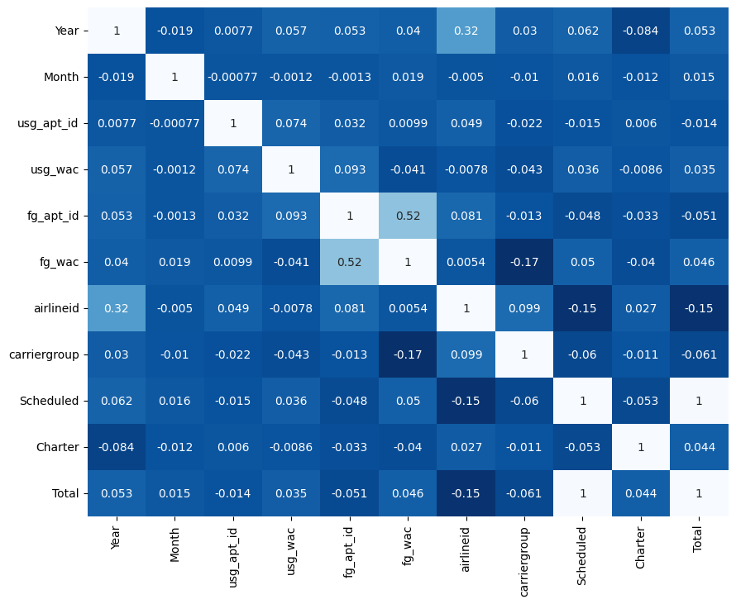

1. **Using POWERBI**

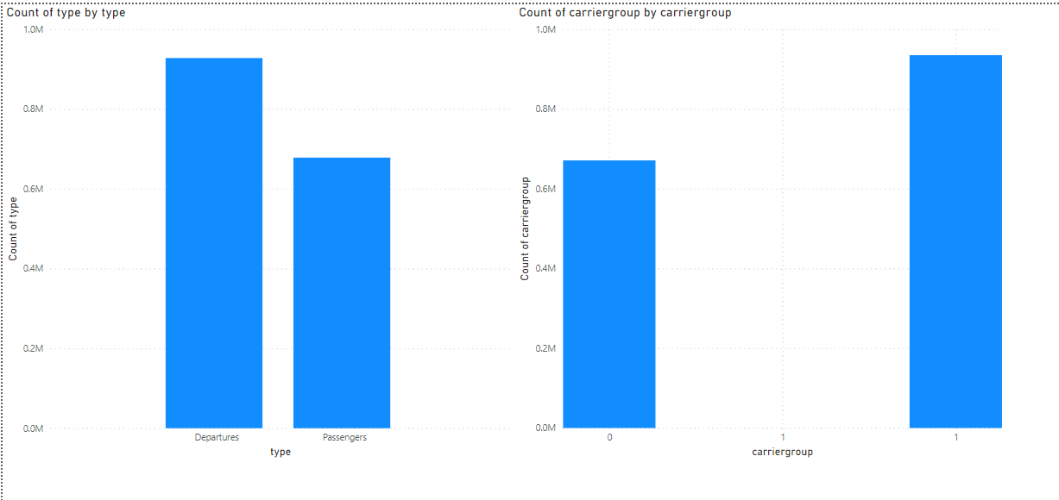

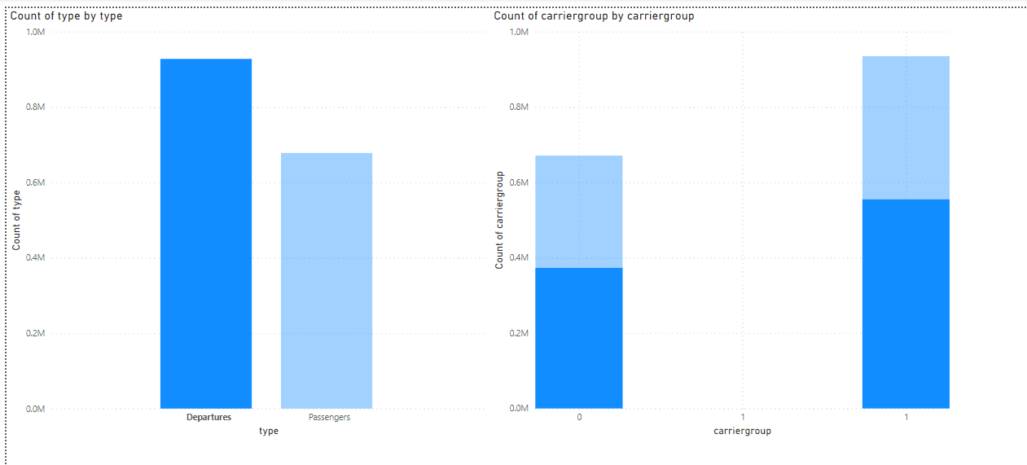

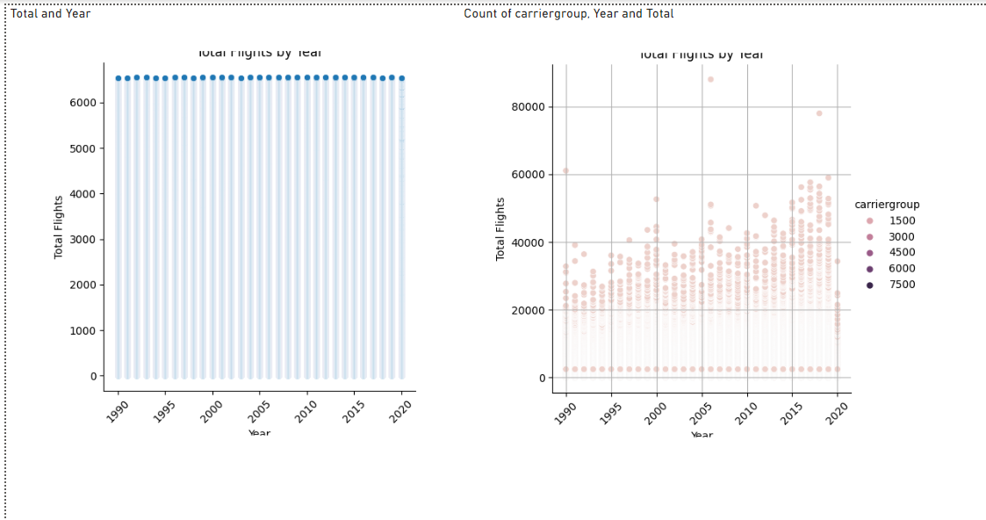

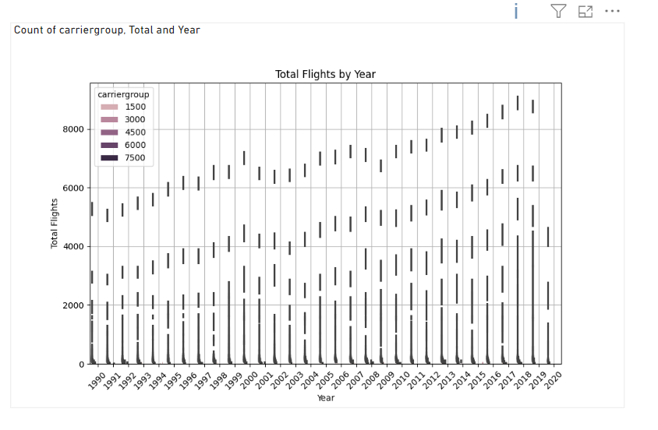

1. **Using Plotly (Python)**

fig = px.histogram(full_data, *x*='type', *color_discrete_sequence*=['deepskyblue'])

fig.update_layout(

*title*='Distribution Of Type',

*title_font_size*=20,

*title_font_color*='black',

*xaxis_title*='Type',

*yaxis_title*='Count',

*xaxis_tickangle*=-60,

*xaxis_showgrid*=True,

*yaxis_showgrid*=True

)

fig.show()

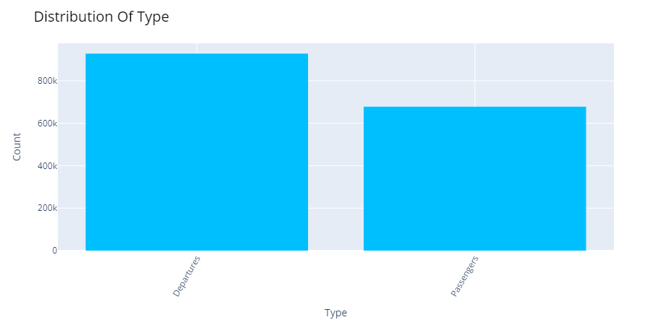

fig = px.histogram(full_data, *x*='carriergroup', *color_discrete_sequence*=['orange'])

fig.update_layout(

*title*='Distribution Of CarrierGroup',

*title_font_size*=20,

*xaxis_title*='CarrierGroup',

*yaxis_title*='Count',

*xaxis_tickangle*=-45,

*xaxis_showgrid*=True,

*yaxis_showgrid*=True

)

fig.show()

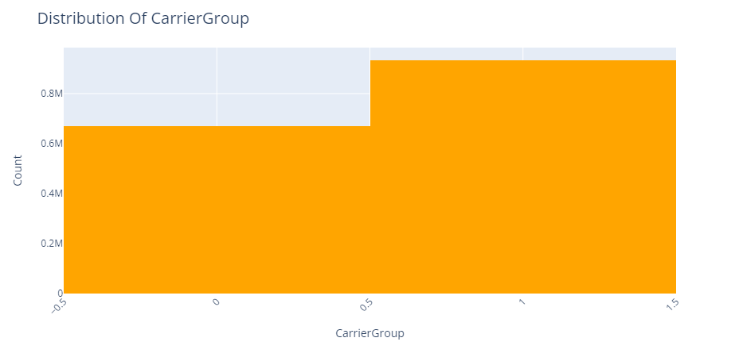

fig = px.line(full_data, *x*='Year', *y*='Total', *line_shape*='linear', *color_discrete_sequence*=['deepskyblue'])

fig.update_layout(

*title*='Total Flights by Year',

*title_font_size*=20,

*xaxis_title*='Year',

*yaxis_title*='Total Flights',

*xaxis_tickangle*=-45

)

fig.show()

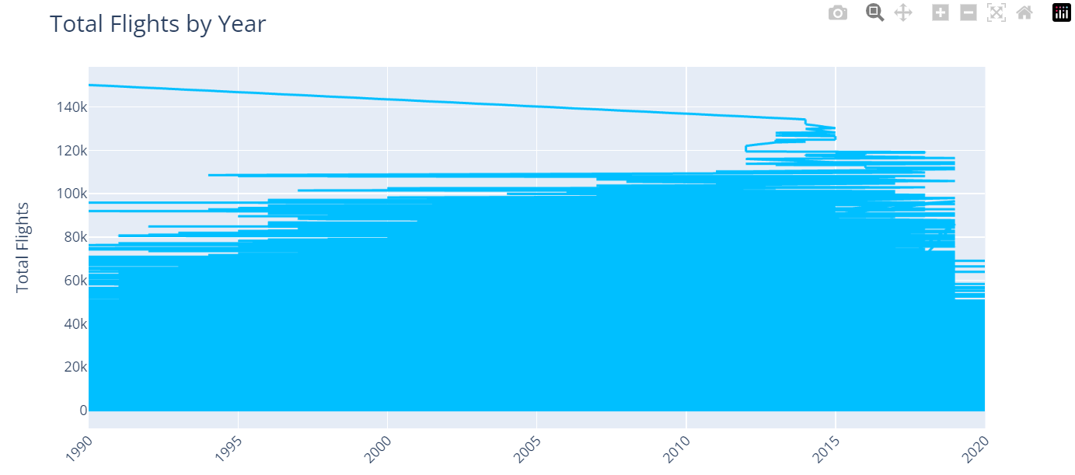

fig = px.line(full_data, *x*='Year', *y*='Total', *color*='carriergroup', *line_shape*='linear', *color_discrete_sequence*=['green'])

fig.update_layout(

*title*='Total Flights by Year',

*title_font_size*=20,

*xaxis_title*='Year',

*yaxis_title*='Total Flights',

*xaxis_tickangle*=-45,

*xaxis_showgrid*=True,

*yaxis_showgrid*=True

)

fig.show()

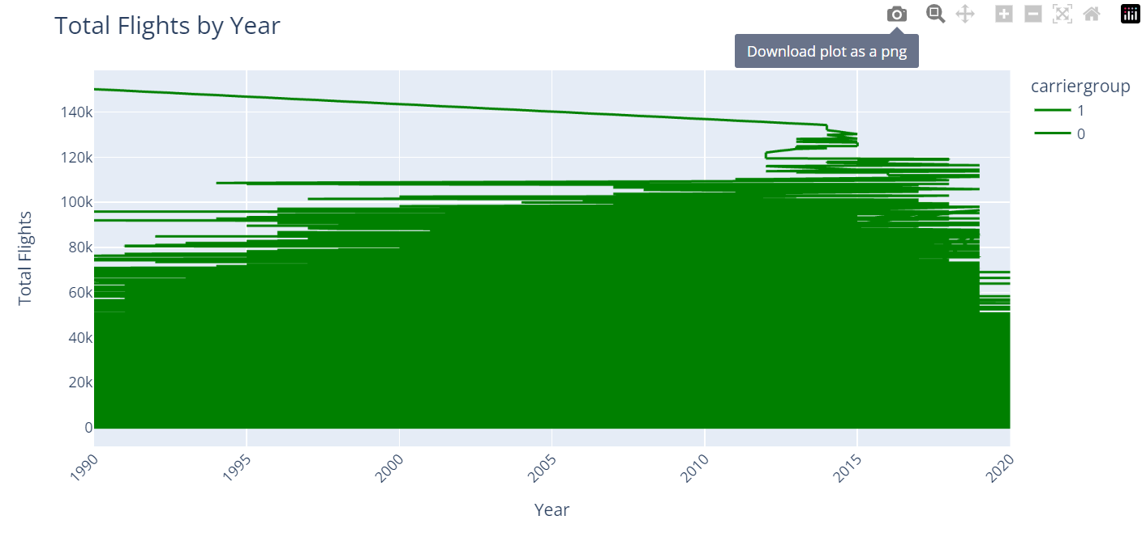

*# Compute the correlation matrix*

numerical_data = full_data.select_dtypes(*include*=['number'])

correlation_matrix = numerical_data.corr()

*# Create the heatmap*

fig = go.Figure(*data*=go.Heatmap(

*z*=correlation_matrix.values,

*x*=correlation_matrix.columns,

*y*=correlation_matrix.columns,

*colorscale*='Blues',

*colorbar_title*='Correlation',

*zmid*=0

))

*# Update layout*

fig.update_layout(

*title*='Correlation Matrix',

*xaxis_title*='Variables',

*yaxis_title*='Variables',

*xaxis_nticks*=len(correlation_matrix.columns),

*yaxis_nticks*=len(correlation_matrix.columns),

*xaxis_tickangle*=-45

)

fig.show()

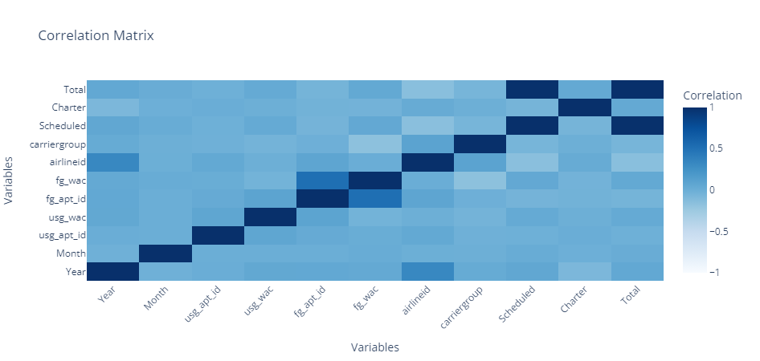

LAB ASSIGNMENT 2

|  |  |  |  |
| --- | --- | --- | --- |
| **Name:** | Harsh Shah | **Roll No.:** | 21BCP359 |
| **Division:** | 6 | **Batch:** | G11 |
| **Aim:** | Measurements of electric power consumption in one household with a one-minute sampling rate over a period of almost 4 years. Different electrical quantities and some sub-metering values are available. | | |

**Objective**

The objective of this lab assignment is to explore and analyse a dataset containing measurements of electric power consumption in a household over a period of almost 4 years. You will perform various data visualization tasks to gain insights into electrical quantities, sub-metering values, and overall trends.

Dataset: <https://archive.ics.uci.edu/dataset/235/individual+household+electric+power+consumption>

**Task – 1: Load the data**

import pandas as pd

import numpy as np

import matplotlib.pyplot as plt

import seaborn as sns

df = pd.read_csv( ./data/household_power_consumption.txt', *sep*=';',  *_values*=['nan', '?'] )

df.index = pd.to_datetime(df['Date'] +' '+ df['Time'], *dayfirst*=True)

df.index.name = 'dt'

df = df.drop(*columns* = ['Date', 'Time'])

*# Data Cleaning*

df.isna().sum()

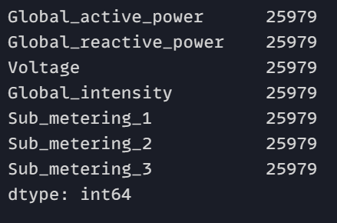

df.dropna(*inplace*=True)

df.isna().sum()

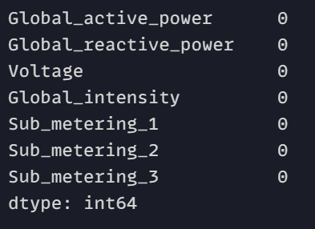

**Task – 2: Subset the data from the given dates (December 2006 and November 2009)**

start_date = pd.Timestamp('2006-12-01')

end_date = pd.Timestamp('2009-11-30')

newdf = df.loc[start_date:end_date]

**Task – 3: Create a histogram**

plt.figure(*figsize*=(14, 10))

for i, column in enumerate(newdf.columns, 1):

    plt.subplot(3, 3, i)

    sns.histplot(newdf[column], *kde*=True, *bins*=10)

    plt.title(*f*'Histogram of {column}')

    plt.xlabel(column)

    plt.ylabel('Frequency')

plt.tight_layout()

plt.show()

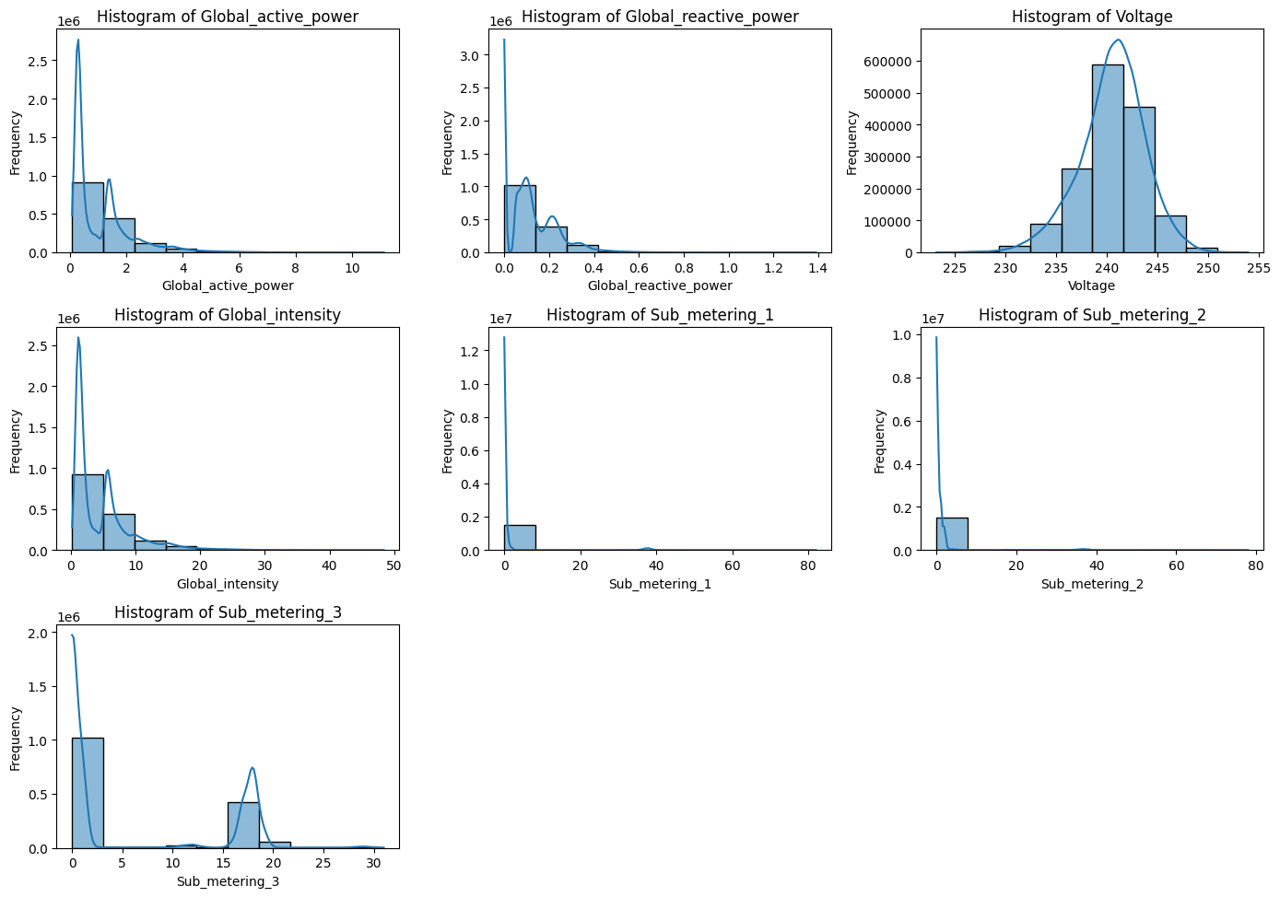

**Task – 4: Create a Time series**

plt.figure(*figsize*=(14, 20))

for i, column in enumerate(newdf.columns, 1):

    plt.subplot(7, 1, i)

    newdf[column].plot(*title*=column, *xlabel*='Date', *ylabel*=column, *legend*=True)

    plt.grid(True)

plt.tight_layout()

plt.show()

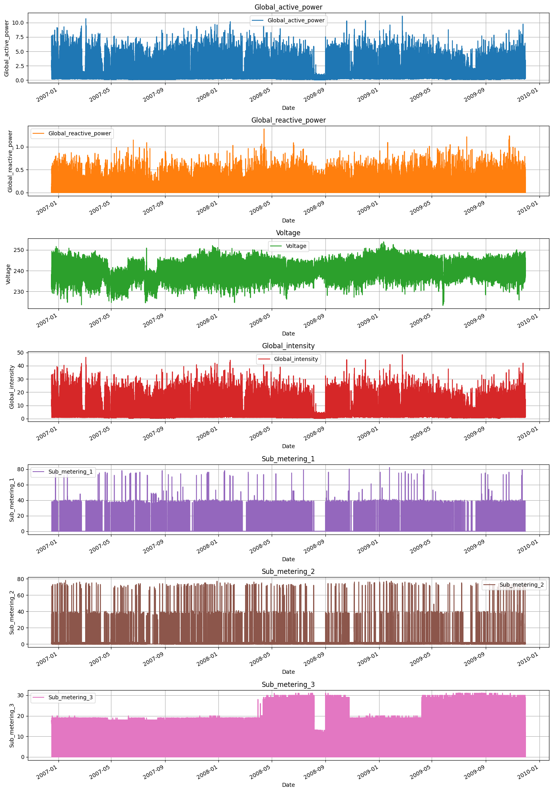

**Task – 5: Create a plot for sub metering**

df_melted = newdf.reset_index().melt(*id_vars*='dt', *value_vars*=['Sub_metering_1', 'Sub_metering_2', 'Sub_metering_3'])

plt.figure(*figsize*=(12, 6))

sns.lineplot(*data*=df_melted, *x*='dt', *y*='value', *hue*='variable')

plt.title('Sub Metering Time Series')

plt.xlabel('Date')

plt.ylabel('Sub Metering Value')

plt.legend(*loc*='upper right')

plt.grid(True)

plt.show()

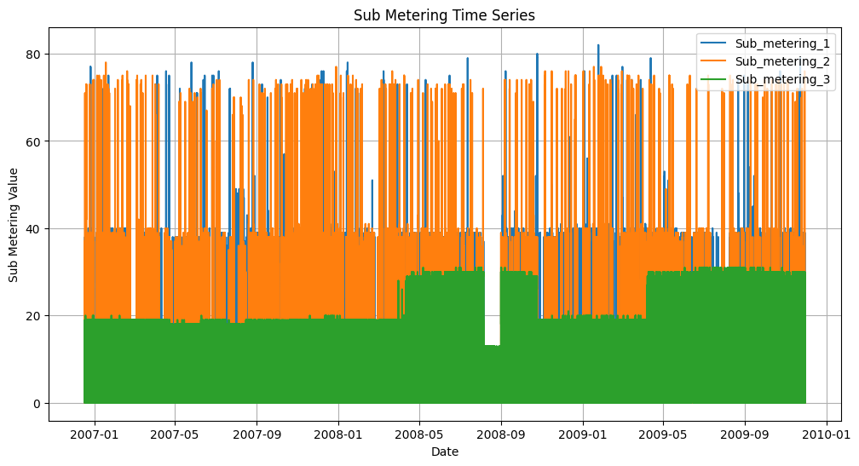

**Task – 6: Create multiple other plots.**

**Scatter Plot**

pairs = [

    ('Global_active_power', 'Global_reactive_power'),

    ('Global_active_power', 'Voltage'),

    ('Global_active_power', 'Global_intensity'),

    ('Global_reactive_power', 'Voltage'),

    ('Global_reactive_power', 'Global_intensity'),

    ('Global_reactive_power', 'Sub_metering_1'),

]

nrows, ncols = 3, 2

fig, axes = plt.subplots(nrows, ncols, *figsize*=(20, 10))

axes = axes.flatten()

for ax, (x_col, y_col) in zip(axes, pairs):

    ax.scatter(newdf[x_col], newdf[y_col], *marker*='o', *alpha*=0.5)

    ax.set_title(*f*'{x_col} vs {y_col}')

    ax.set_xlabel(x_col)

    ax.set_ylabel(y_col)

    ax.grid(True)

plt.tight_layout()

plt.show()

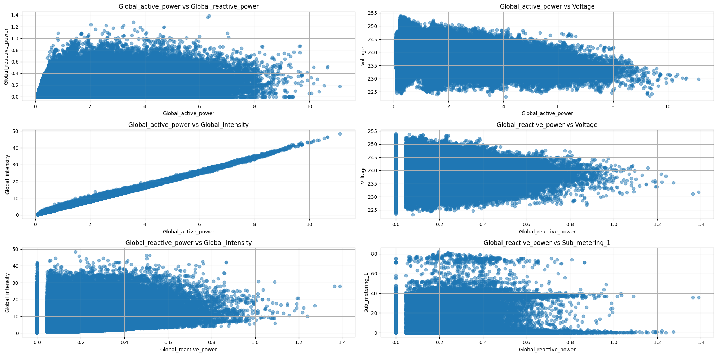

**Bar Chart**

monthly_data = newdf.resample('ME').sum()

monthly_data[['Global_active_power', 'Global_reactive_power']].plot(*kind*='bar', *figsize*=(12, 6))

plt.title('Monthly Total of Global Active Power and Global Reactive Power')

plt.xlabel('Month')

plt.ylabel('Power (kW)')

plt.grid(True)

plt.show()

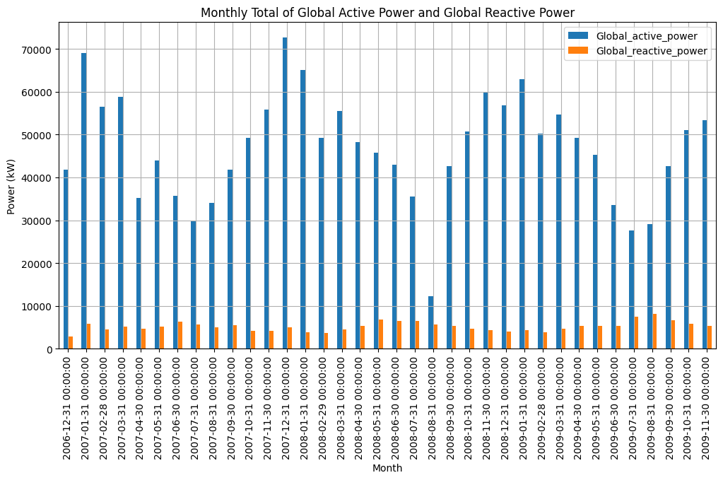

monthly_sub_metering = newdf[['Sub_metering_1', 'Sub_metering_2', 'Sub_metering_3']].resample('ME').sum()

monthly_sub_metering.plot(*kind*='bar', *stacked*=True, *figsize*=(12, 6))

plt.title('Monthly Total of Sub Metering 1, 2, and 3')

plt.xlabel('Month')

plt.ylabel('Total Sub Metering')

plt.grid(True)

plt.show()

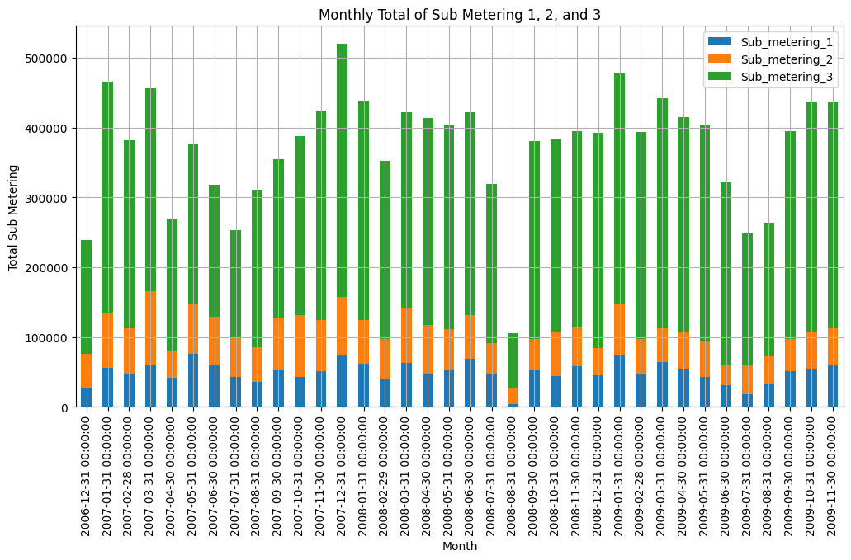

**Pie Chart**

total_sub_metering = monthly_sub_metering.sum()

plt.figure(*figsize*=(5, 5))

plt.pie(total_sub_metering, *labels*=total_sub_metering.index, *autopct*='%1.1f%%', *startangle*=140)

plt.title('Total Contribution of Sub Metering Over Entire Period')

plt.show()

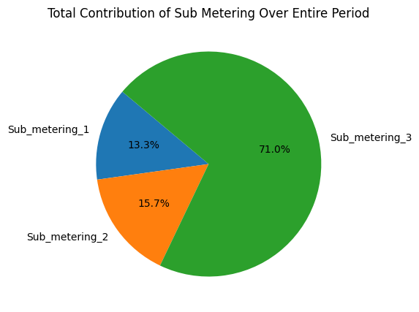

**Box Plot**

columns_to_plot = ['Global_active_power', 'Global_reactive_power', 'Voltage',

                    'Global_intensity', 'Sub_metering_1', 'Sub_metering_2', 'Sub_metering_3']

fig, axes = plt.subplots(*nrows*=4, *ncols*=2, *figsize*=(18, 20))

axes = axes.flatten()

for i, column in enumerate(columns_to_plot):

    sns.boxplot(*x*=newdf[column], *ax*=axes[i])

    axes[i].set_title(*f*'Box Plot of {column}')

    axes[i].grid(True)

plt.tight_layout()

plt.show()

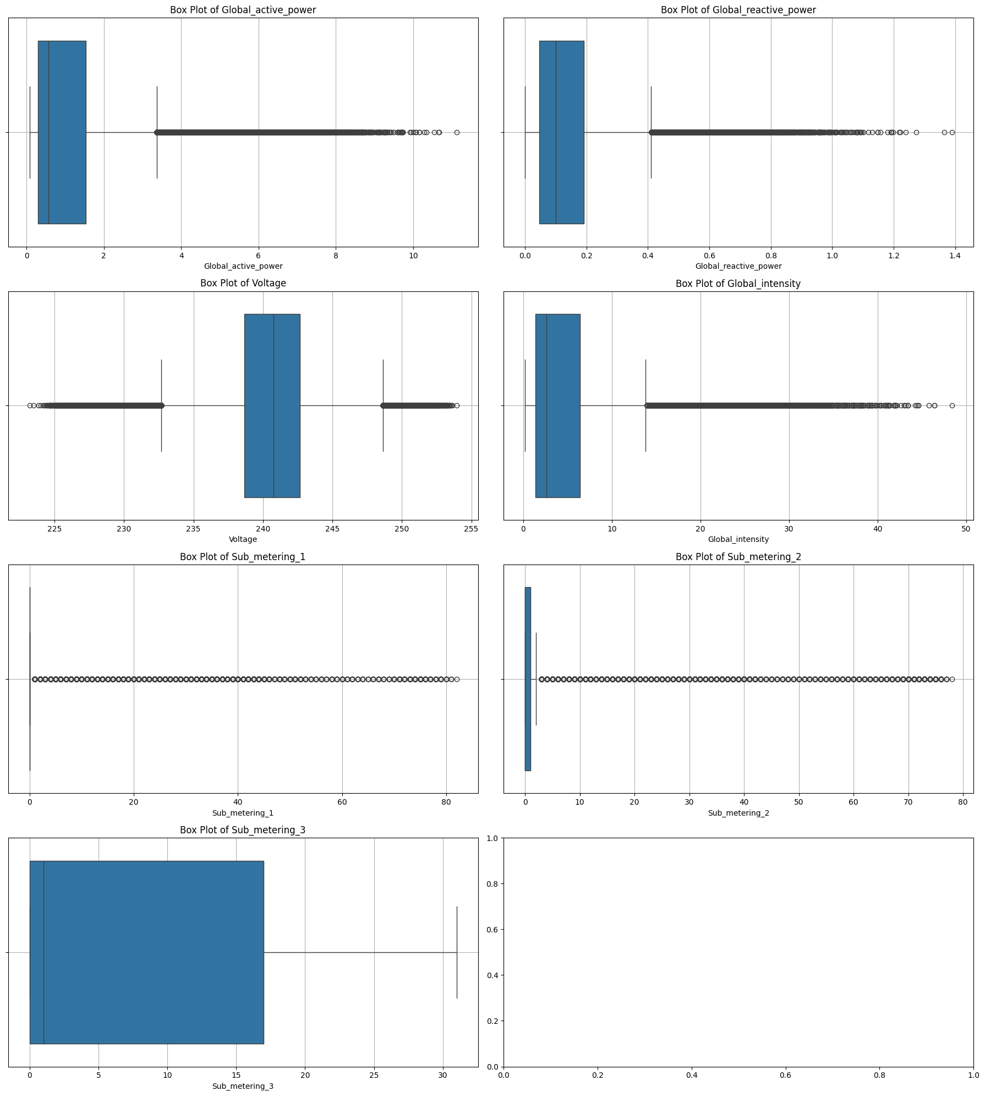

**Count Plot**

hourly_data = newdf[['Sub_metering_1', 'Sub_metering_2', 'Sub_metering_3']].resample('h').sum()

hourly_data['Hour'] = hourly_data.index.hour

hourly_data_melted = hourly_data.melt(*id_vars*='Hour', *var_name*='Sub_metering', *value_name*='Total')

plt.figure(*figsize*=(12, 6))

sns.countplot(*x*='Hour', *data*=hourly_data_melted, *hue*='Sub_metering', *palette*='viridis')

plt.title('Count of Hourly Sub Metering Usage')

plt.xlabel('Hour of Day')

plt.ylabel('Count')

plt.legend(*title*='Sub Metering')

plt.grid(True)

plt.show()

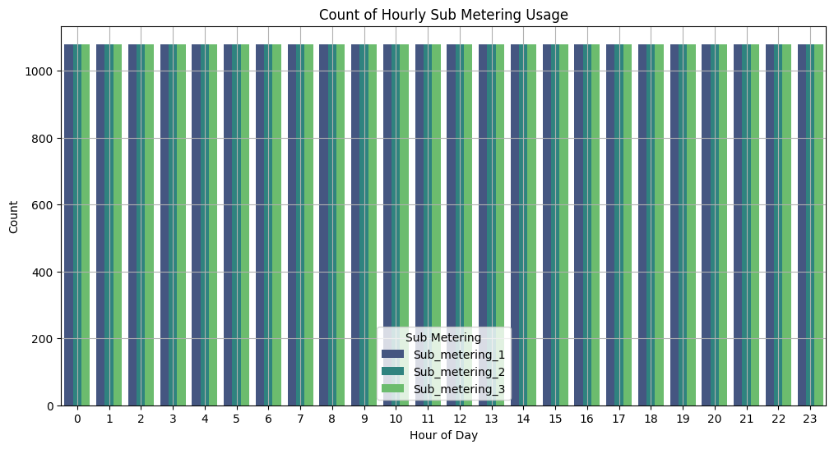

**Distplot**

columns_to_plot = ['Global_active_power', 'Global_reactive_power', 'Voltage',

                    'Global_intensity', 'Sub_metering_1', 'Sub_metering_2', 'Sub_metering_3']

plt.figure(*figsize*=(18, 16))

for i, column in enumerate(columns_to_plot):

    plt.subplot(4, 2, i + 1)

    sns.histplot(newdf[column], *kde*=True, *color*='blue', *bins*=20)

    plt.title(*f*'Distribution of {column}')

    plt.xlabel('Value')

    plt.ylabel('Frequency')

plt.tight_layout()

plt.show()

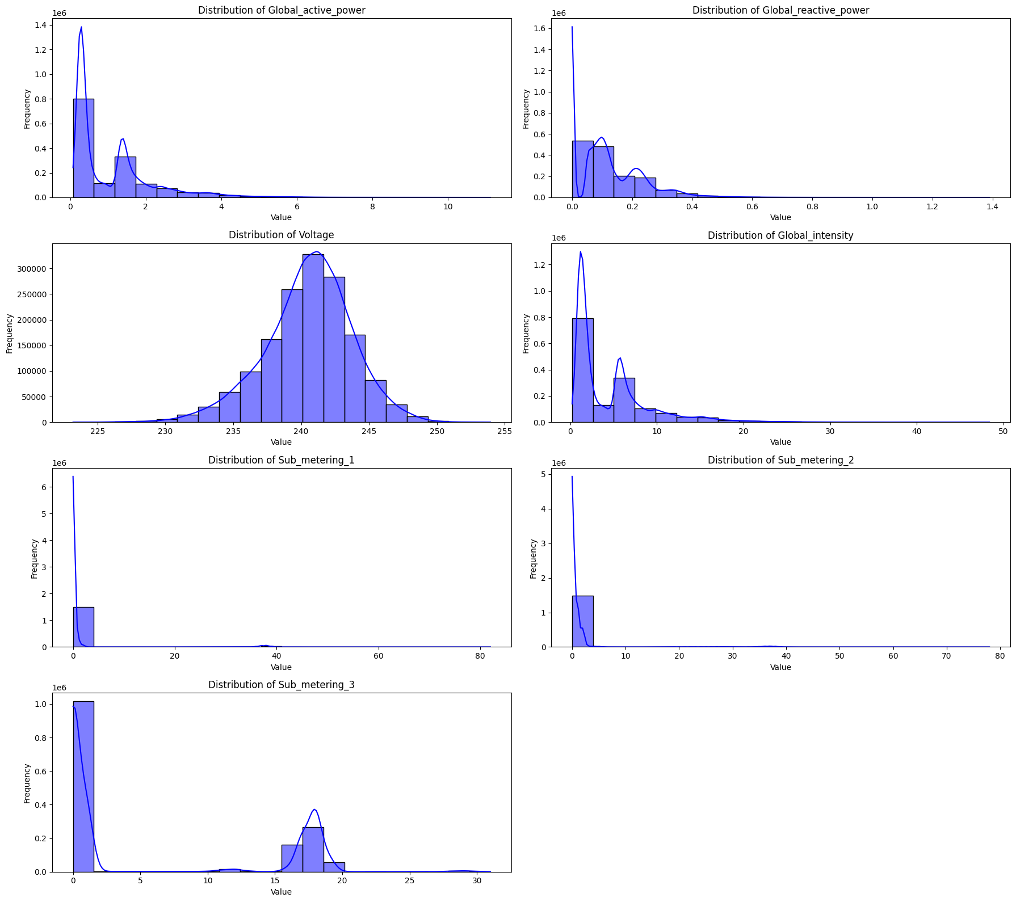

**Heatmap**

correlation_matrix = newdf.corr()

plt.figure(*figsize*=(12, 10))

sns.heatmap(correlation_matrix, *annot*=True, *fmt*='.2f', *linewidths*=0.5, *vmin*=-1, *vmax*=1)

plt.title('Correlation Matrix Heatmap')

plt.show()

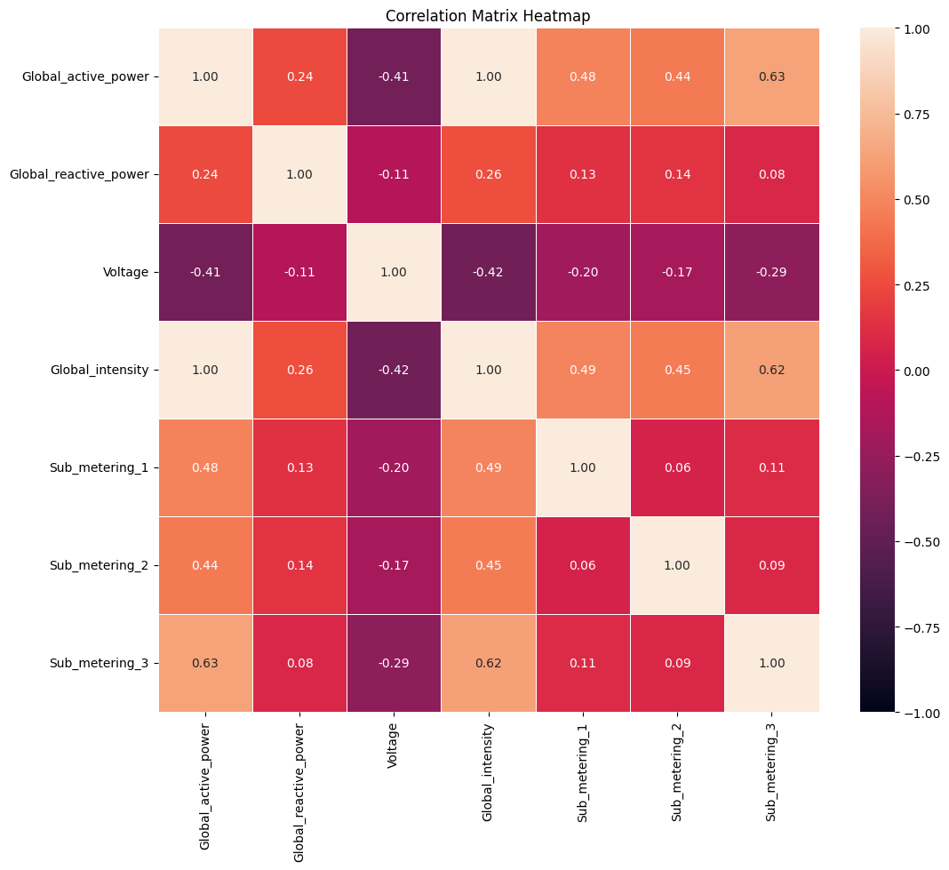

**Visualise Each Parameter Early**

*def* visualize_yearly(*data*, *feat_name*):

    fig, axis = plt.subplots(4, 1, *figsize*=(30, 20))

    for i, d in enumerate(zip(axis, *list*(data[feat_name].groupby(data.index.year)))):

        d[0].plot(pd.DataFrame(d[1][1]), *label*=d[1][0])

        d[0].legend(*loc*='upper right')

    fig.text(0.40, 0.9, 'Year-Wise Analysis : %s ' % feat_name, *va*='center', *fontdict*={'fontsize': 25})

    plt.show()

visualize_yearly(*data*=newdf, *feat_name*='Global_active_power')

visualize_yearly(*data*=newdf, *feat_name*='Global_reactive_power')

visualize_yearly(*data*=newdf, *feat_name*='Voltage')

visualize_yearly(*data*=newdf, *feat_name*='Global_intensity')

visualize_yearly(*data*=newdf, *feat_name*='Sub_metering_1')

visualize_yearly(*data*=newdf, *feat_name*='Sub_metering_2')

visualize_yearly(*data*=newdf, *feat_name*='Sub_metering_3')

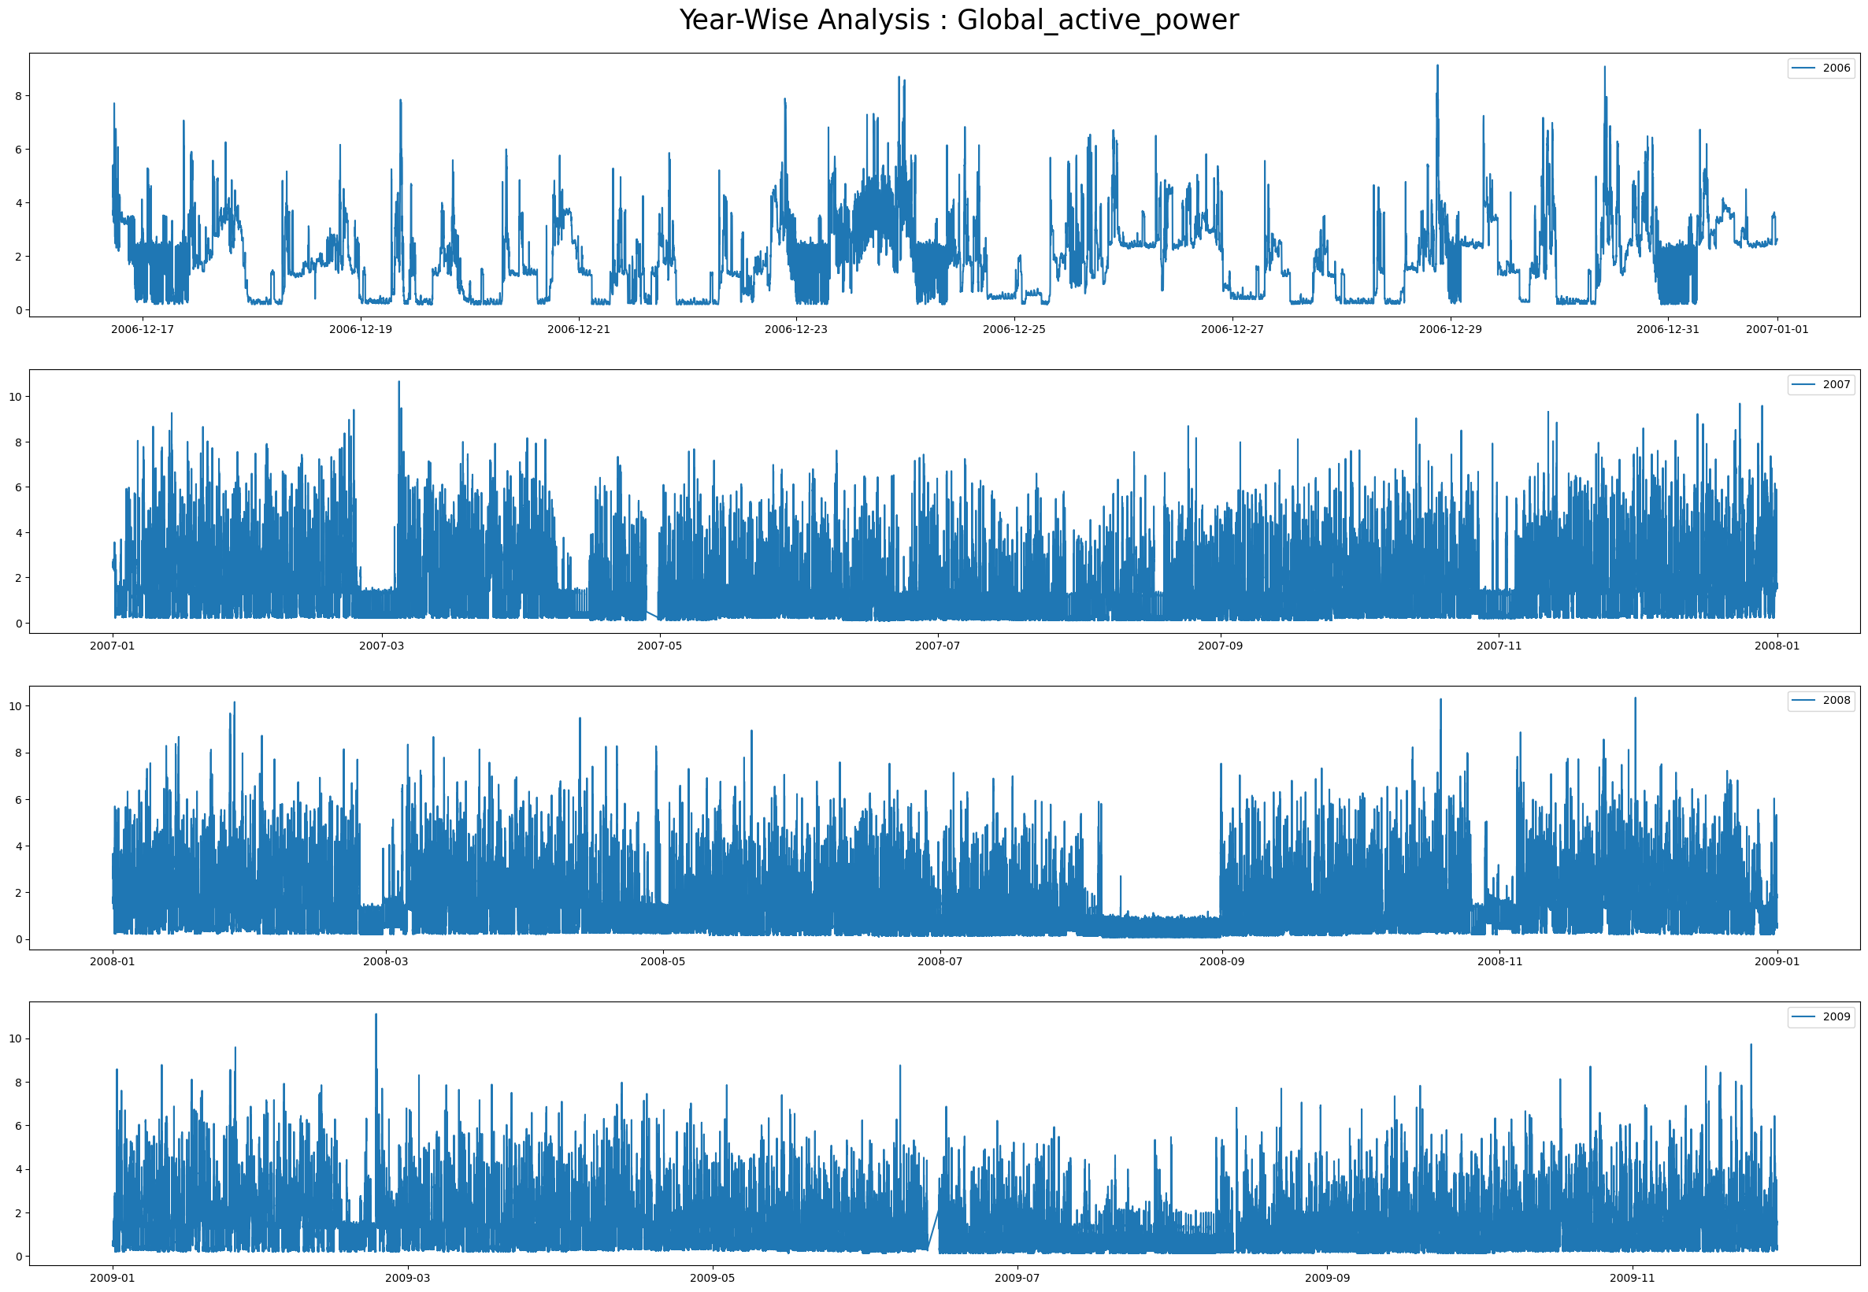

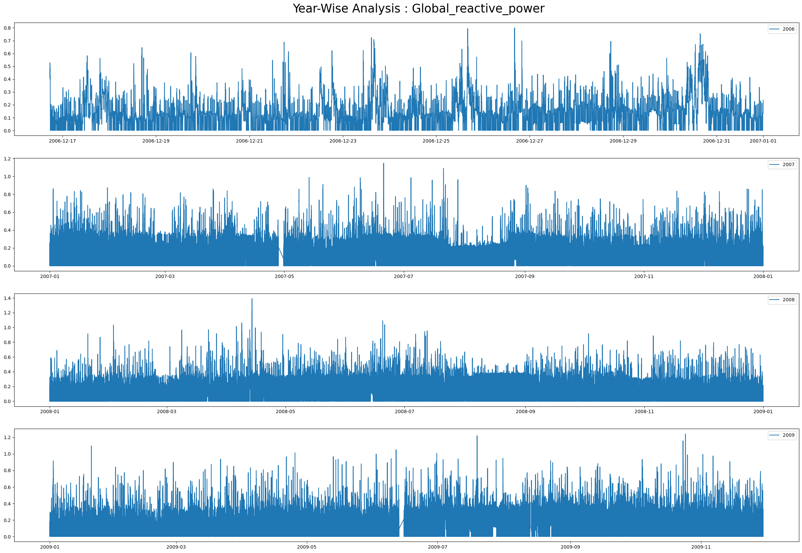

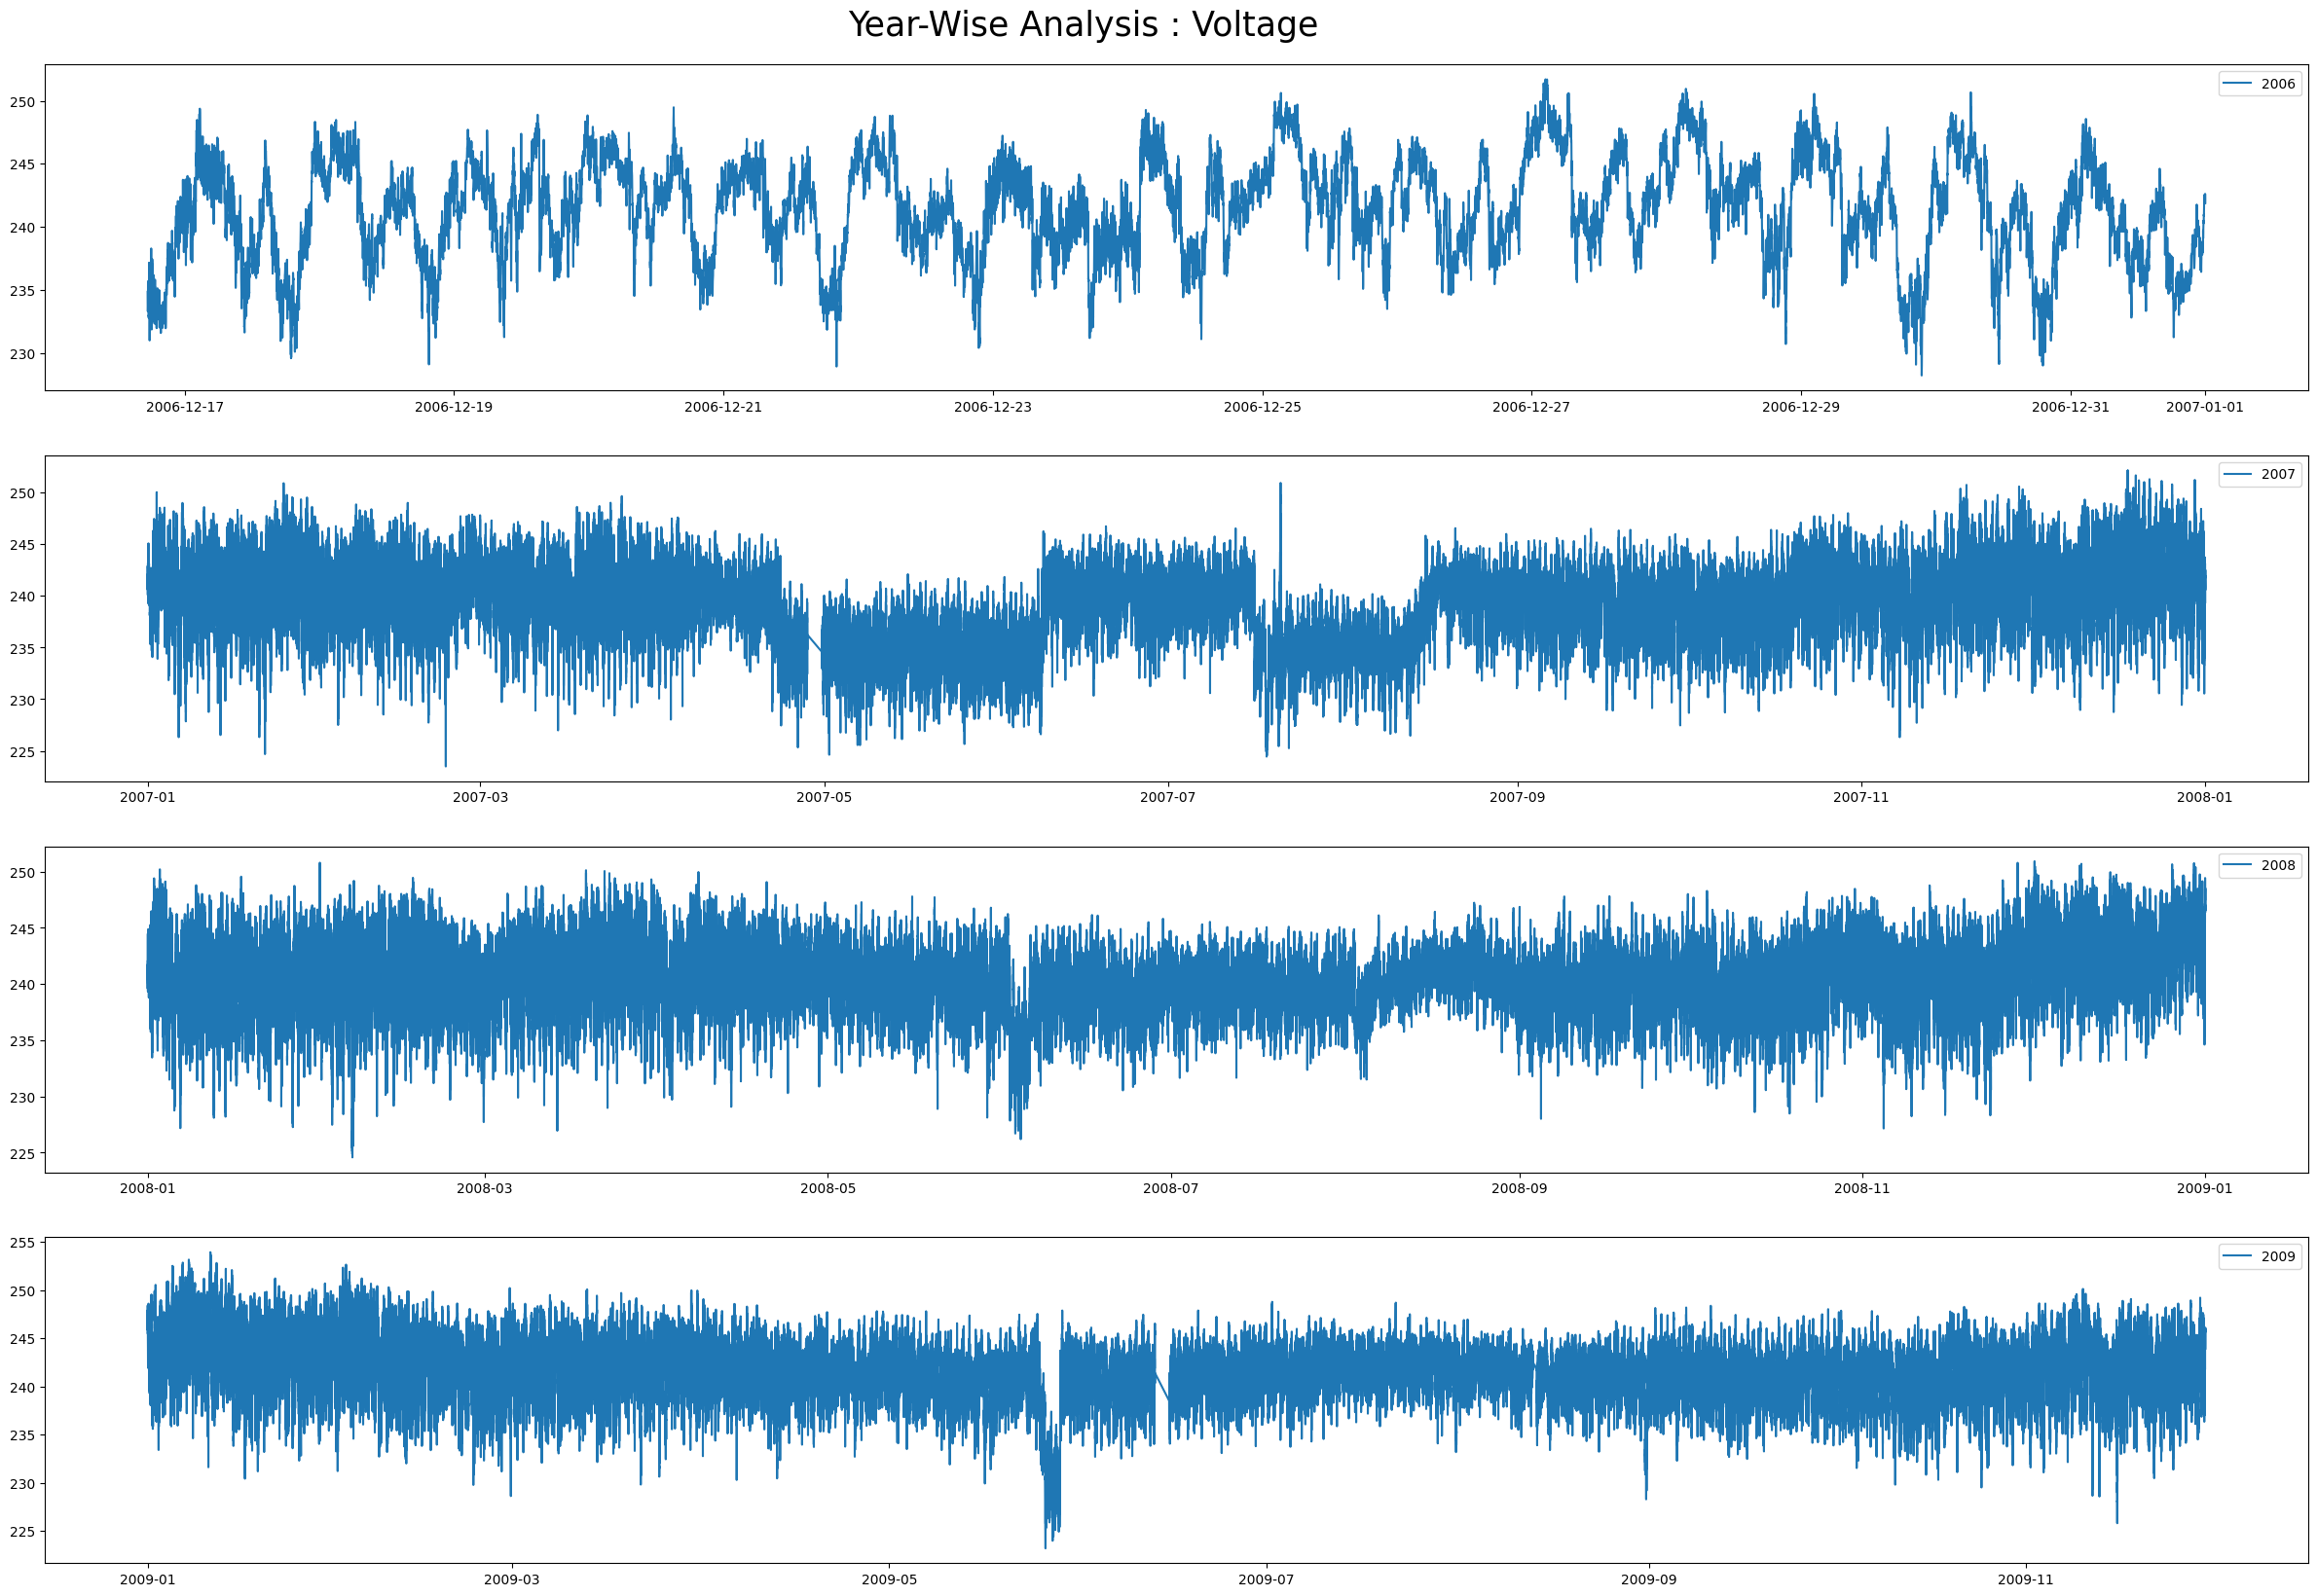

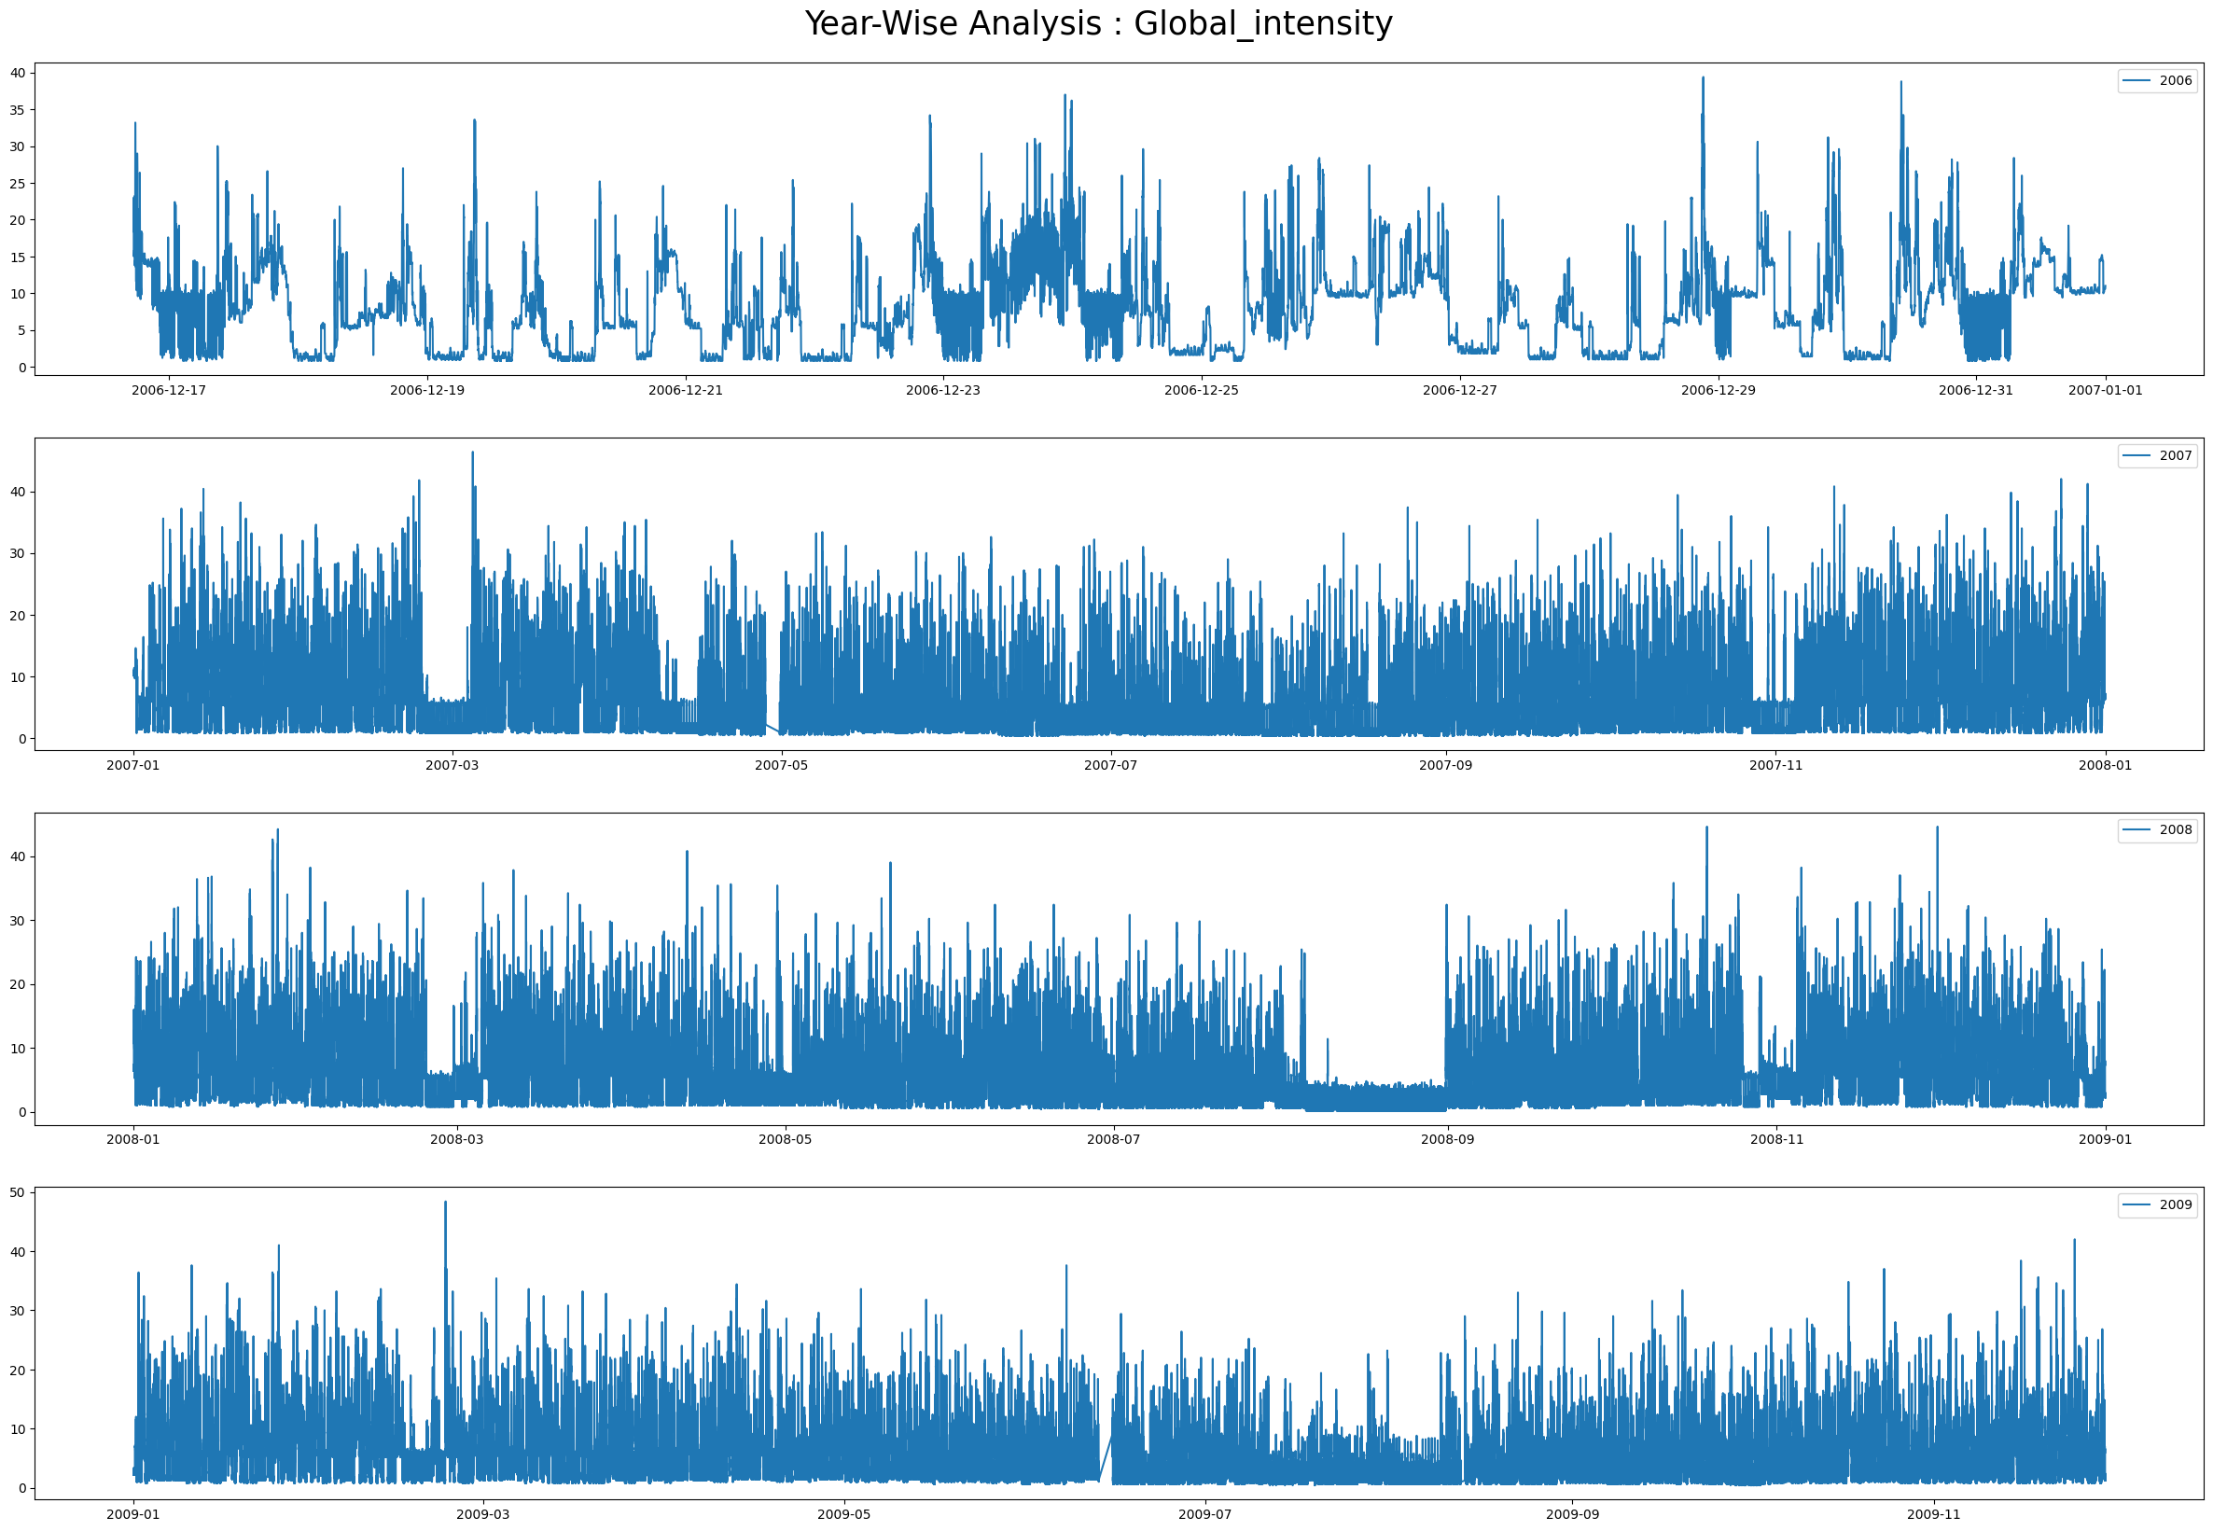

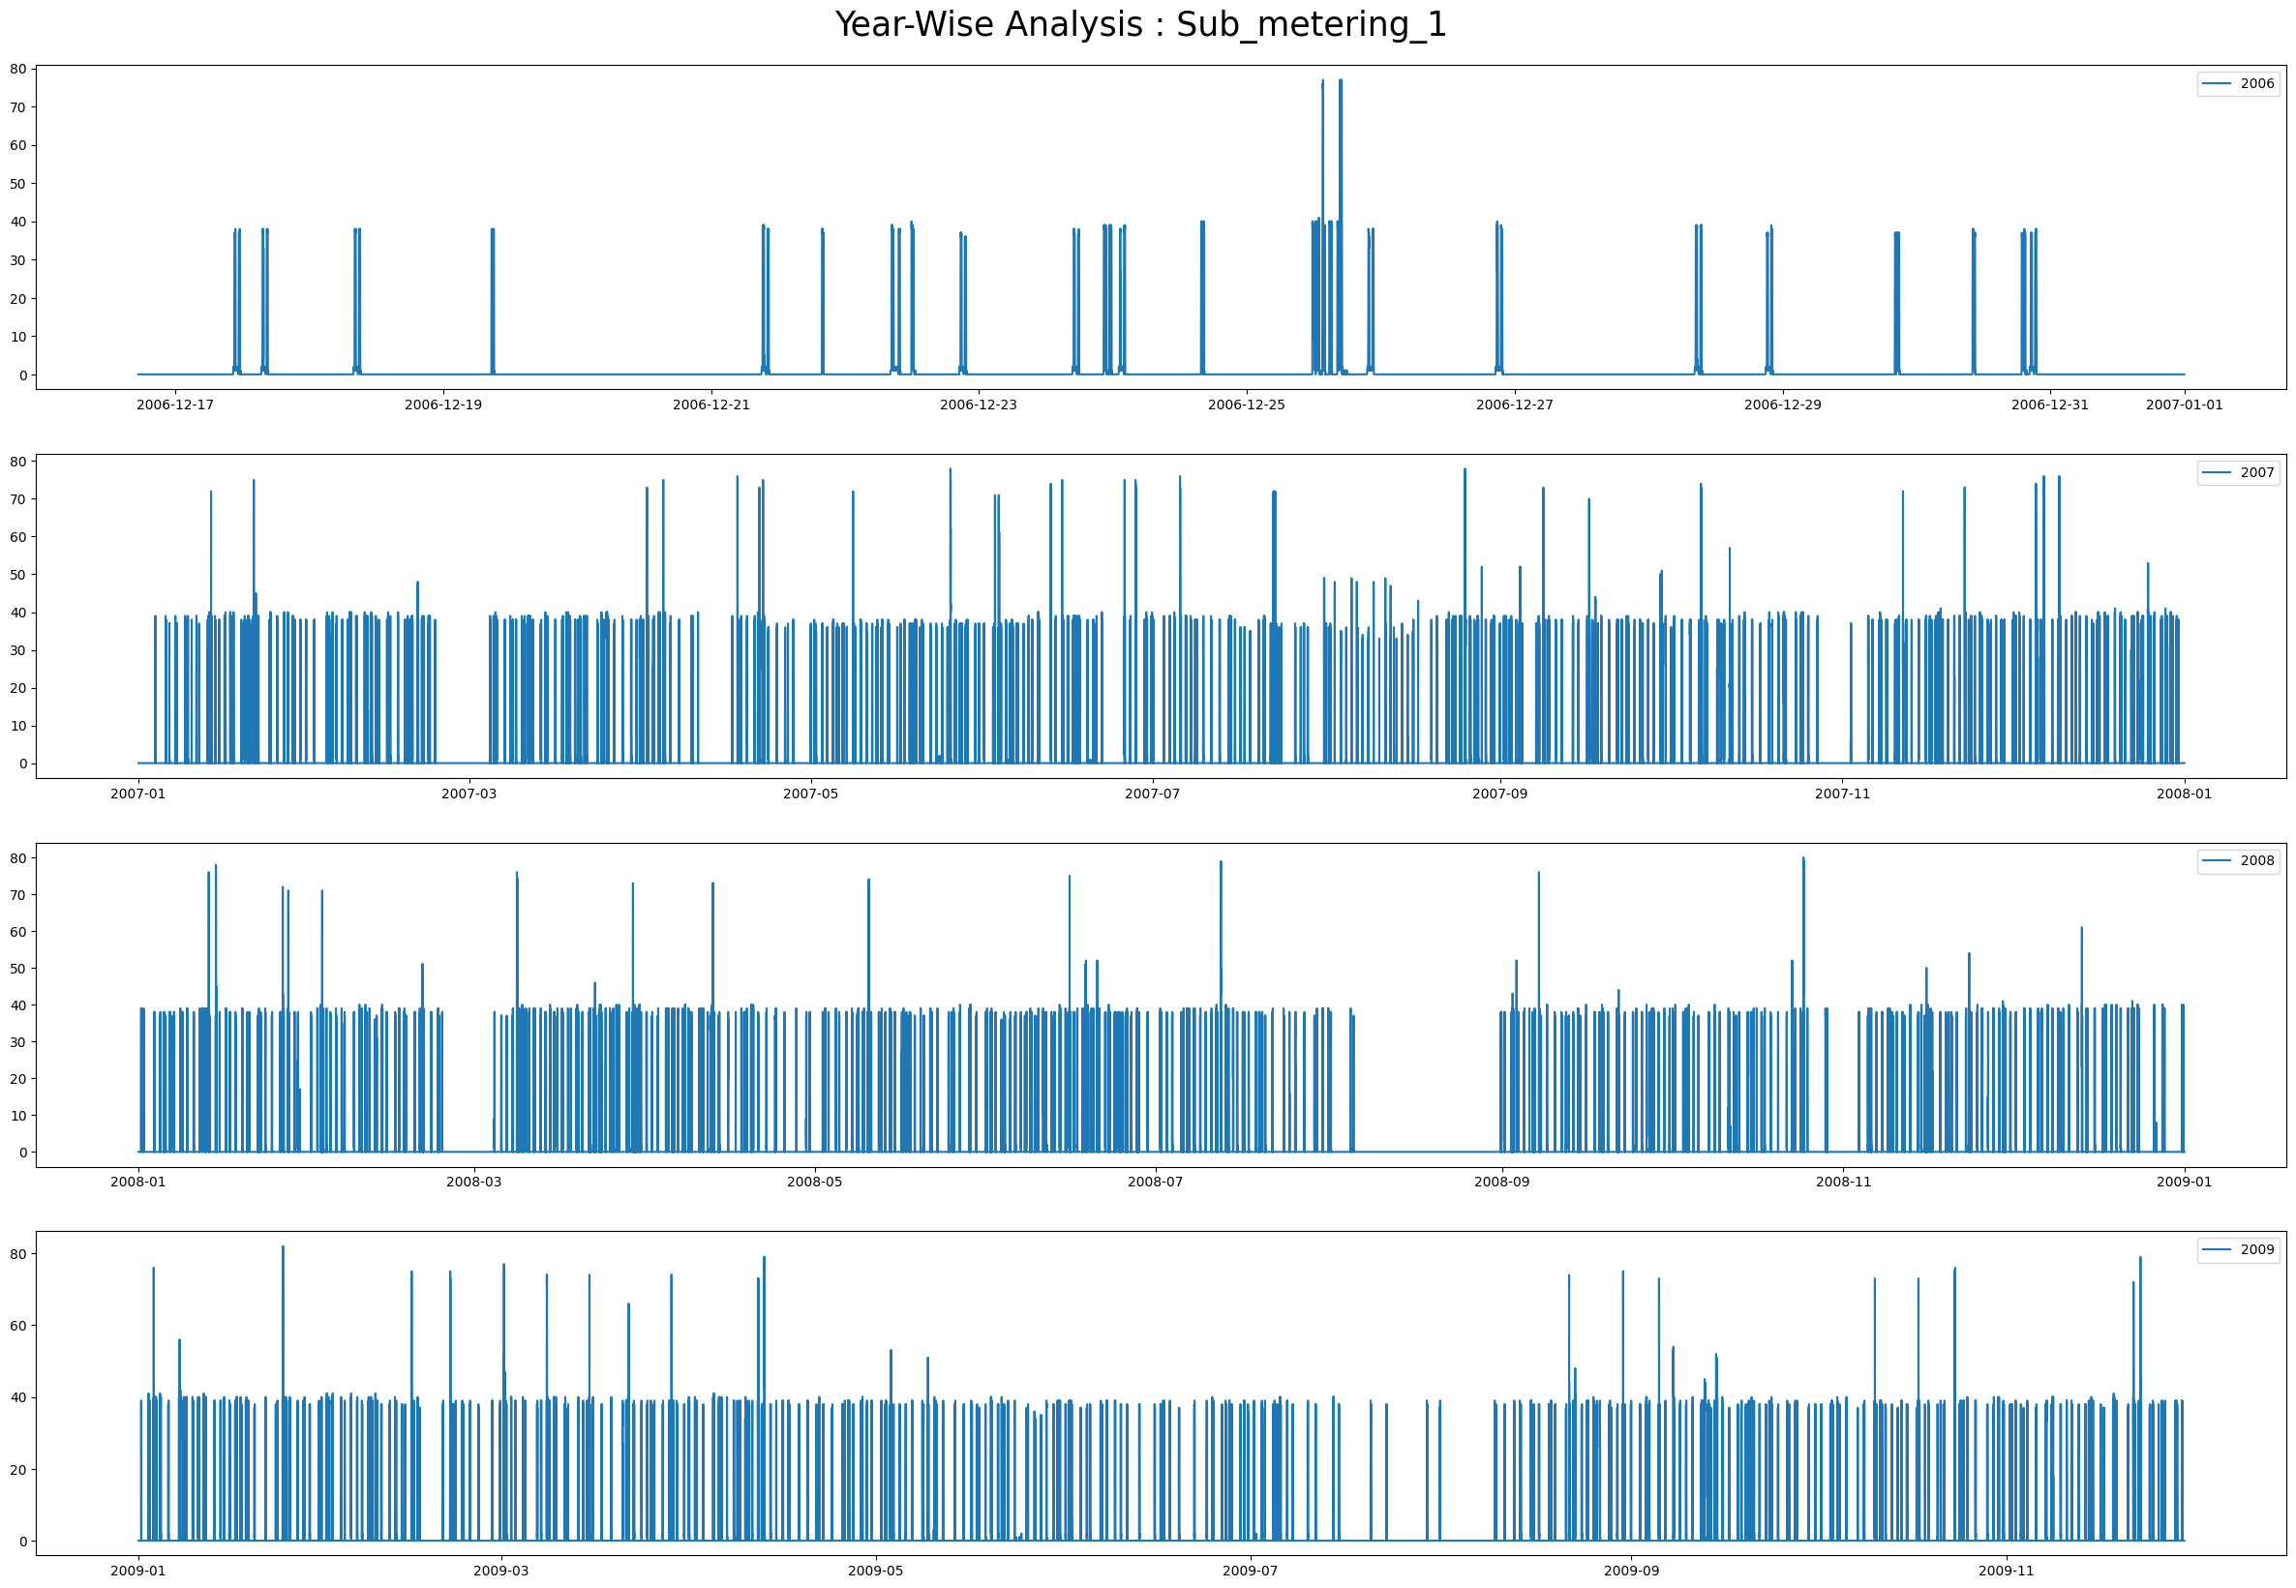

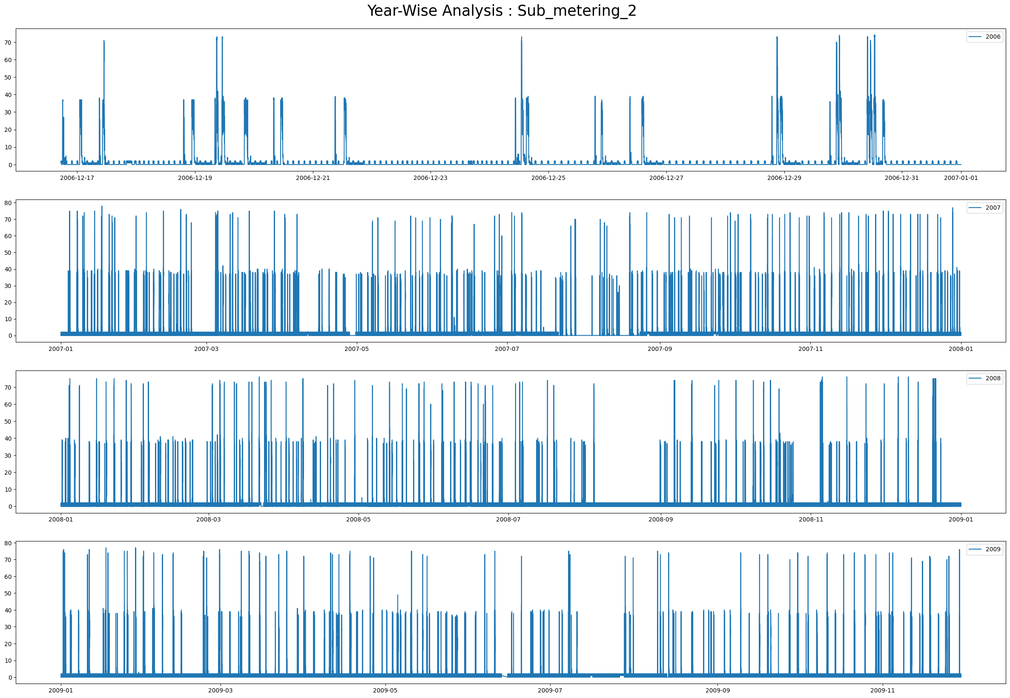

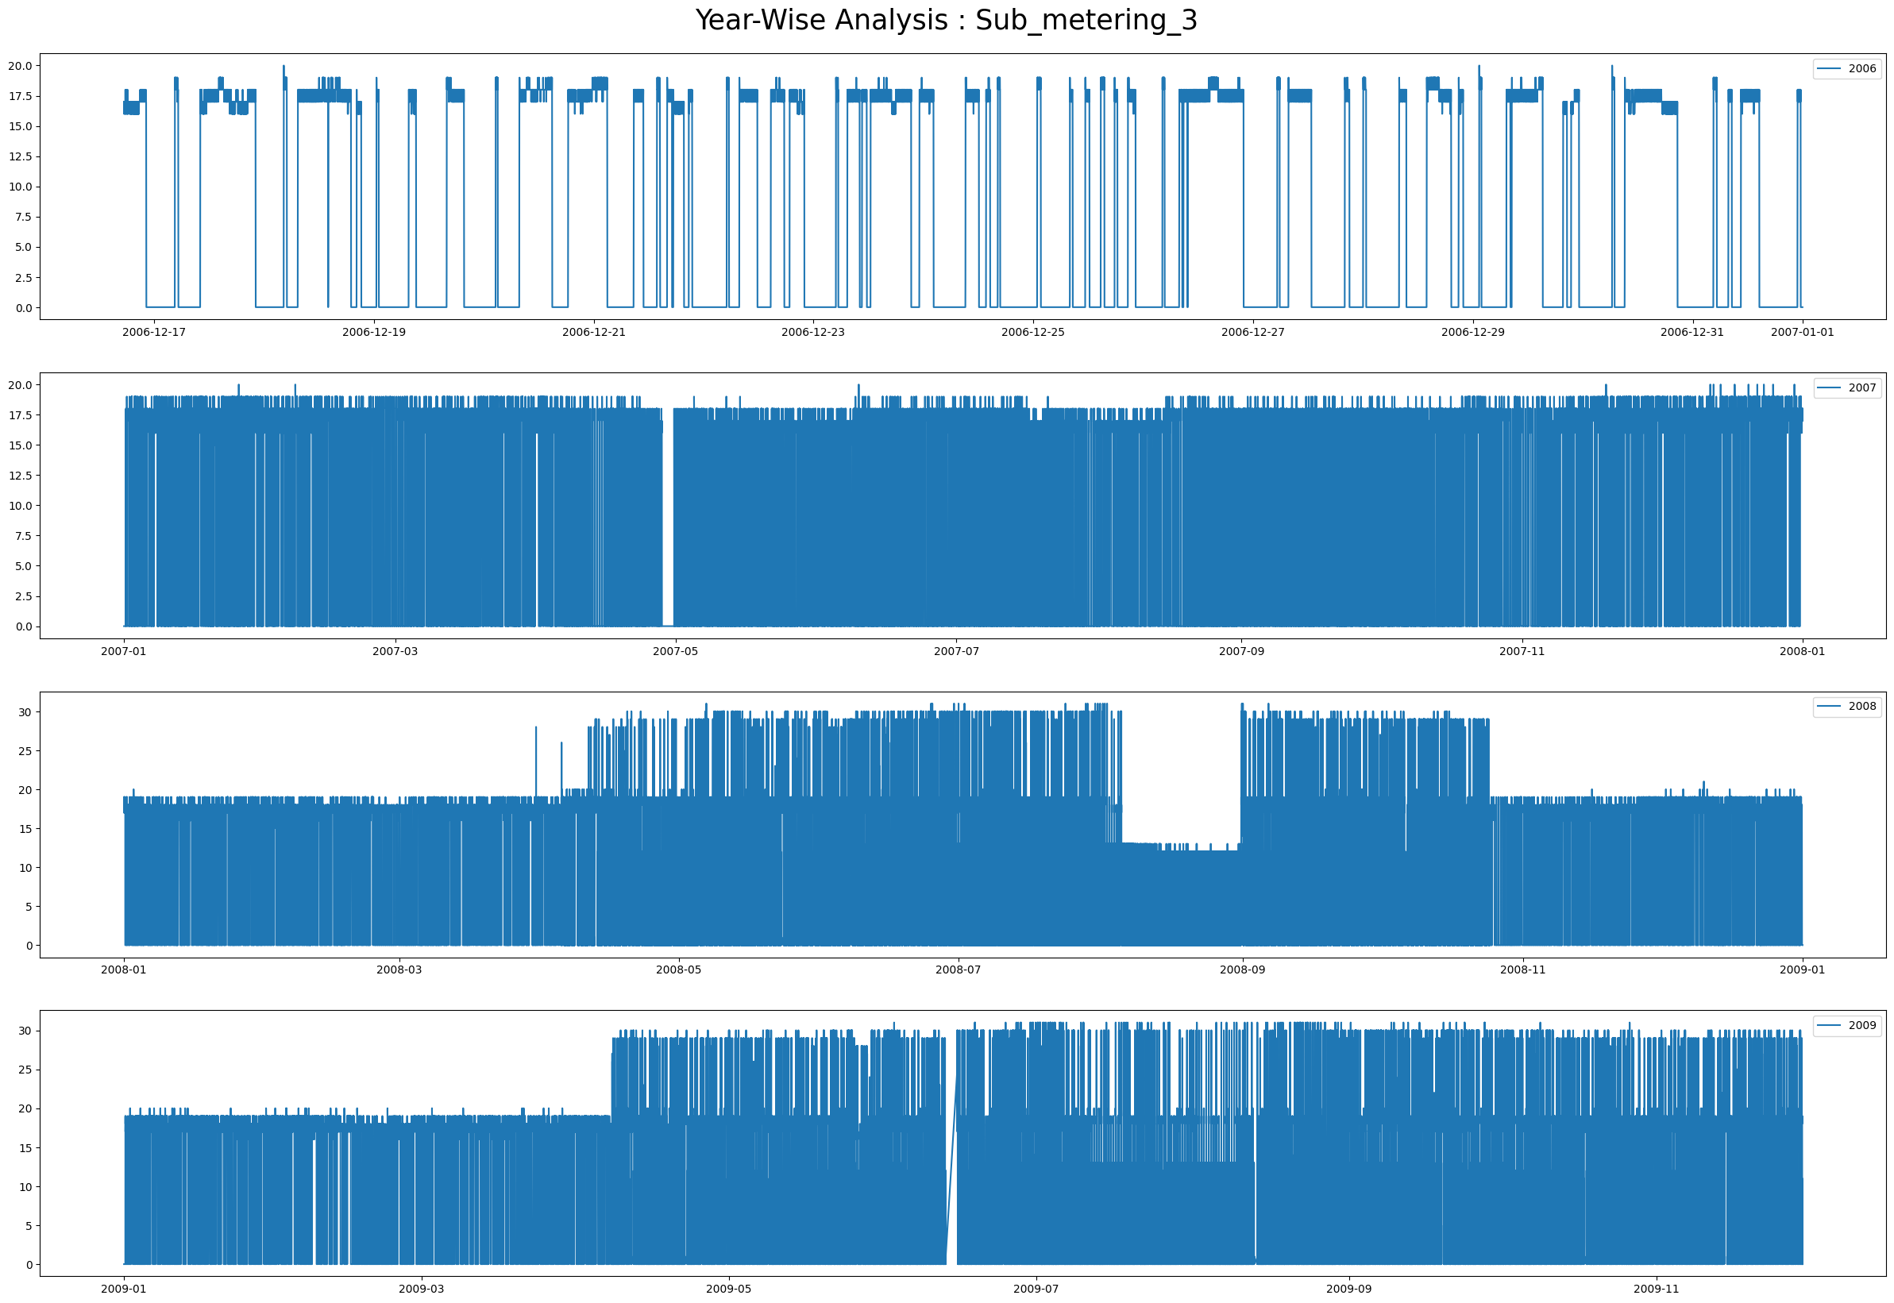

**Use of each type of plot**

* **Histogram**: Ideal for understanding the distribution of power consumption levels.
* **Time Series Plot**: Best for analysing trends and patterns over the 4-year period.
* **Plot for Sub Metering**: Key for comparing the contributions of different sub-meters over time.
* **Scatterplot**: Useful for examining relationships between two continuous variables.
* **Bar Chart**: Great for comparing quantities across different time periods.
* **Pie Chart**: Shows proportions of sub-metering contributions to total consumption.
* **Count Plot**: Displays the frequency of different power consumption categories.
* **Boxplot**: Summarizes distributions and highlights outliers in consumption data.
* **Heatmap**: Effective for identifying correlations and patterns across variables and time.
* **Distplot**: Combines a histogram and KDE to show a detailed distribution.

LAB ASSIGNMENT 3

|  |  |  |  |
| --- | --- | --- | --- |
| **Name:** | Harsh Shah | **Roll No.:** | 21BCP359 |
| **Division:** | 6 | **Batch:** | G11 |
| **Aim:** | Implement simple and multi-linear regression to predict profits for a food truck. Compare the performance of the model on linear and multi-linear regression. | | |

**Objective**

The objective of this lab assignment is to implement simple and multi-linear regression models to predict profits for a food truck business. By comparing the performance of these two regression models, you will gain insights into when and how to use simple and multi-linear regression techniques.

**Steps**

1. **Data Preparation**:

* Construct a numpy array containing both features (Population, Years in Business) and the target variable (Profit).
* Separate the data into feature set XXX and target variable yyy.
* Address any missing values in yyy by substituting NaN with the average of yyy.

1. **Simple Linear Regression**:

* Develop a function called simple_linear_regression to compute the coefficients (β0\beta_0β0​, β1\beta_1β1​), make predictions, and calculate the mean squared error (MSE) for a single feature (Years in Business).
* Extract the Years in Business as X_simple and apply the simple linear regression model.

1. **Multiple Linear Regression**:

* Create a function named multi_linear_regression to determine coefficients, predictions, and MSE using all features.
* Prepare the feature set X_multi by adding a column of ones for the intercept term and then perform the multiple linear regression analysis.

1. **Plotting**:

* Generate two subplots:
  + The first subplot will display the results of the simple linear regression (Years in Business vs. Profit).
  + The second subplot will illustrate the results of the multiple linear regression (Population vs. Profit).
* Show both actual and predicted values in these plots.

1. **Print Results**:

* Print out the coefficients, intercepts, and MSE for both the simple and multiple linear regression models.

**Code**

import numpy as np

import matplotlib.pyplot as plt

data = np.array(

    [

        [10000, 5, 10000],

        [15000, 6, 12000],

        [20000, 6, 13000],

        [9000, 5, 12000],

        [12000, 4, np.nan],

    ]

)

X = data[:, :-1]

y = data[:, -1]

mean_y = np.nanmean(y)

y[np.isnan(y)] = mean_y

*def* simple_linear_regression(*X_simple*, *y*):

    X_simple_mean = np.mean(X_simple)

    y_mean = np.mean(y)

    beta1 = np.sum((X_simple - X_simple_mean) * (y - y_mean)) / np.sum(

        (X_simple - X_simple_mean) ** 2

    )

    beta0 = y_mean - beta1 * X_simple_mean

    y_pred = beta0 + beta1 * X_simple

    mse = np.mean((y - y_pred) ** 2)

    return beta0, beta1, y_pred, mse

*def* multi_linear_regression(*X_multi*, *y*):

    XTX = np.dot(X_multi.T, X_multi)

    XTX_inv = np.linalg.inv(XTX)

    XTy = np.dot(X_multi.T, y)

    beta = np.dot(XTX_inv, XTy)

    y_pred = np.dot(X_multi, beta)

    mse = np.mean((y - y_pred) ** 2)

    return beta, y_pred, mse

X_simple = X[:, 1]

beta0, beta1, y_pred_simple, mse_simple = simple_linear_regression(X_simple, y)

X_multi = np.hstack([np.ones((X.shape[0], 1)), X])

beta_multi, y_pred_multi, mse_multi = multi_linear_regression(X_multi, y)

plt.figure(*figsize*=(14, 6))

plt.subplot(1, 2, 1)

plt.scatter(X_simple, y, *color*="blue", *label*="Actual Profit")

plt.plot(

    X_simple, y_pred_simple, *color*="red", *linewidth*=2, *label*="Simple Linear Regression"

)

plt.xlabel("Years in Business")

plt.ylabel("Profit")

plt.title(*f*"Simple Linear Regression\nMSE = {mse_simple*:.2f*}")

plt.legend()

plt.subplot(1, 2, 2)

X_population = X[:, 0]

plt.scatter(X_population, y, *color*="blue", *label*="Actual Profit")

plt.scatter(

    X_population,

    y_pred_multi,

*color*="green",

*marker*="x",

*label*="Multi-Linear Regression Predictions",

)

plt.xlabel("Population")

plt.ylabel("Profit")

plt.title(*f*"Multi-Linear Regression\nMSE = {mse_multi*:.2f*}")

plt.legend()

plt.show()

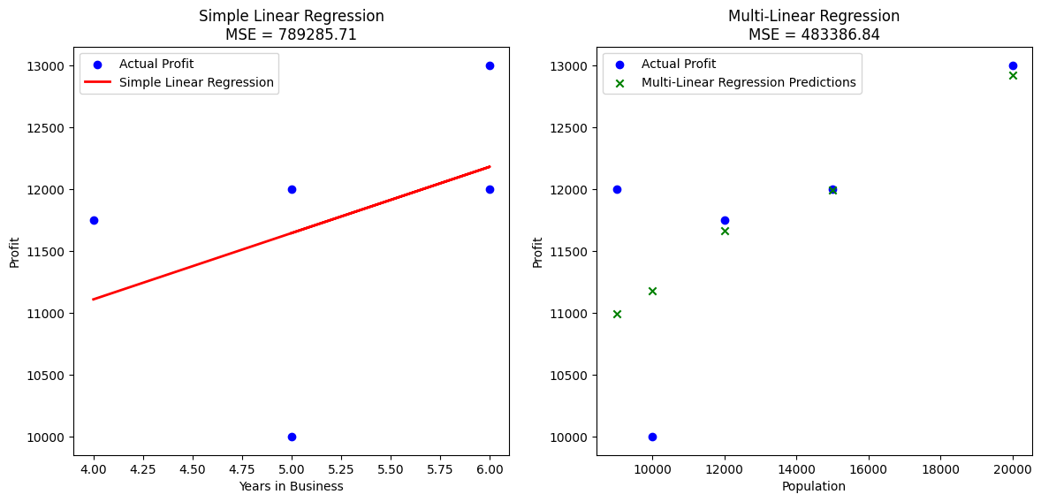

X = np.array([[10000], [15000], [20000], [9000]])

y = np.array([10000, 12000, 13000, 12000])

Population_mean = X.mean()

Population_std = X.std()

Population_normalized = (X - Population_mean) / Population_std

X = np.hstack((np.ones((X.shape[0], 1)), Population_normalized))

y = y

w = np.zeros(X.shape[1])

learning_rate = 0.01

n_iterations = 1000

*def* predict(*X*, *w*):

    return X.dot(w)

*def* compute_cost(*X*, *y*, *w*):

    m = len(y)

    predictions = predict(X, w)

    cost = (1 / (2 * m)) * np.sum((predictions - y) ** 2)

    return cost

*def* gradient_descent(*X*, *y*, *w*, *learning_rate*, *n_iterations*):

    m = len(y)

    cost_history = []

    for i in range(n_iterations):

        predictions = predict(X, w)

        errors = predictions - y

        gradients = (1 / m) * X.T.dot(errors)

        w -= learning_rate * gradients

        cost = compute_cost(X, y, w)

        cost_history.append(cost)

    return w, cost_history

w, cost_history = gradient_descent(X, y, w, learning_rate, n_iterations)

print(*f*"Final weights: {w}")

plt.figure(*figsize*=(12, 6))

plt.plot(range(len(cost_history)), cost_history)

plt.xlabel("Iterations")

plt.ylabel("Cost (Loss)")

plt.title("Cost Function over Iterations")

plt.grid(True)

plt.show()

**Output**

**Final weights: [11749.49273784 769.20068232]**

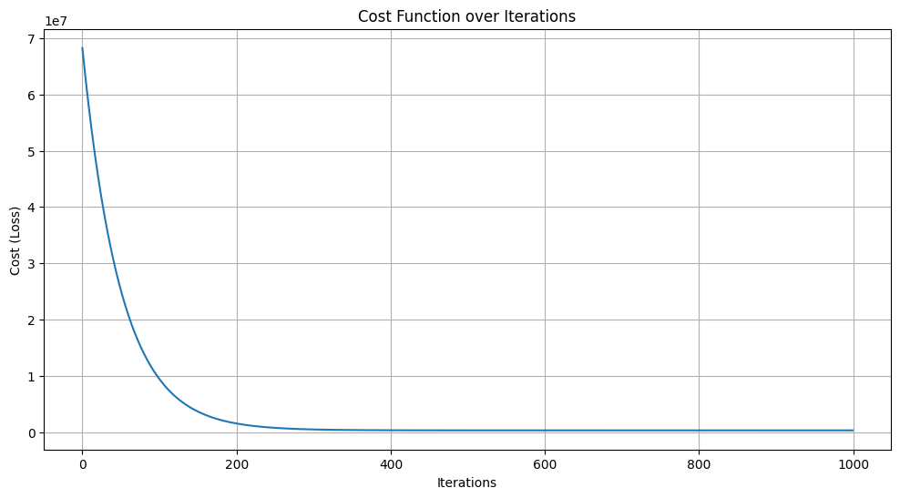

LAB ASSIGNMENT 4

|  |  |  |  |
| --- | --- | --- | --- |
| **Name:** | Harsh Shah | **Roll No.:** | 21BCP359 |
| **Division:** | 6 | **Batch:** | G11 |
| **Aim:** | Implement the non-parametric Locally Weighted Regression algorithm in order to fit data points. Select appropriate data set for your experiment and draw graphs | | |

**Objective**

To fit data points by assigning different weights to each point based on its proximity to the query point.

**Dataset:** Synthetic sinusoidal patterned data (Generated using *numpy* library)

**Code**

import numpy as np

import matplotlib.pyplot as plt

***# Generate Dataset and splitting into features and target vars***

We generate 80 random data points X uniformly distributed between 0 and 5. The target variable y is generated by taking the sine of X and adding some random noise to simulate real-world data.

np.random.seed(0)

X = np.sort(5 * np.random.rand(80, 1), axis=0)

y = np.sin(X).ravel() + np.random.normal(0, 0.1, X.shape[0])

***# Normal Linear Regression***

*def* normal_equation_linear_regression(*X*, *y*):

    m = X.shape[0]

    X_augmented = np.hstack([np.ones((m, 1)), X])

    XTX = np.dot(X_augmented.T, X_augmented)

    XTX_inv = np.linalg.pinv(XTX)

    theta = np.dot(XTX_inv, np.dot(X_augmented.T, y))

    return theta

theta = normal_equation_linear_regression(X, y)

*def* predict(*X*, *theta*):

    m = X.shape[0]

    X_augmented = np.hstack([np.ones((m, 1)), X])

    y_pred = np.dot(X_augmented, theta)

    return y_pred

y_pred = predict(X, theta)

plt.figure(*figsize*=(12, 8))

plt.scatter(X, y, *label*="Training Data", *color*="blue")

plt.plot(X, y_pred, *color*="red", *linewidth*=2, *label*="Linear Regression Fit")

plt.xlabel("X")

plt.ylabel("y")

plt.title("Normal Linear Regression")

plt.legend()

plt.show()

print(*f*"Intercept: {theta[0]}")

print(*f*"Coefficient: {theta[1]}")

***# Implementation of Locally Weighted Regression algorithm***

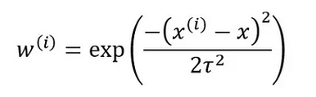 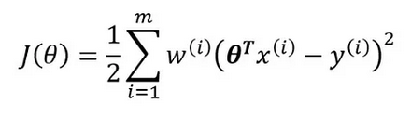

*def*  lwlr(*X*, *y*, *x_query*, *tau*):

    m = X.shape[0]

    W = np.exp(-np.sum((X - x_query) ** 2, *axis*=1) / (2 * tau**2))

    W = np.diag(W)

    X_augmented = np.hstack([np.ones((m, 1)), X])

    x_query_augmented = np.array([1, x_query.item()]).reshape(1, 2)

    XTWX = np.dot(np.dot(X_augmented.T, W), X_augmented)

    XTWy = np.dot(np.dot(X_augmented.T, W), y)

    theta = np.linalg.solve(XTWX, XTWy)

    y_query = np.dot(x_query_augmented, theta)

    return y_query

*def* predict_lwlr(*X*, *y*, *X_query*, *tau*):

    y_pred = np.array([lwlr(X, y, x_query, tau) for x_query in X_query])

    return y_pred

***# Using Multiple Query Points***

X_query = np.linspace(0, 5, 100).reshape(-1, 1)

taus = [0.1, 0.3, 0.8, 2.0]

predictions = {}

for tau in taus:

    predictions[tau] = predict_lwlr(X, y, X_query, tau)

***# Plotting the Graph***

plt.figure(*figsize*=(12, 8))

plt.scatter(X, y, *label*="Training Data", *color*="blue")

for tau in taus:

    plt.plot(X_query, predictions[tau], *linewidth*=2, *label*=*f*"Tau = {tau}")

plt.xlabel("X")

plt.ylabel("y")

plt.title("Locally Weighted Linear Regression with Different values of Tau")

plt.legend()

plt.show()

**Output**

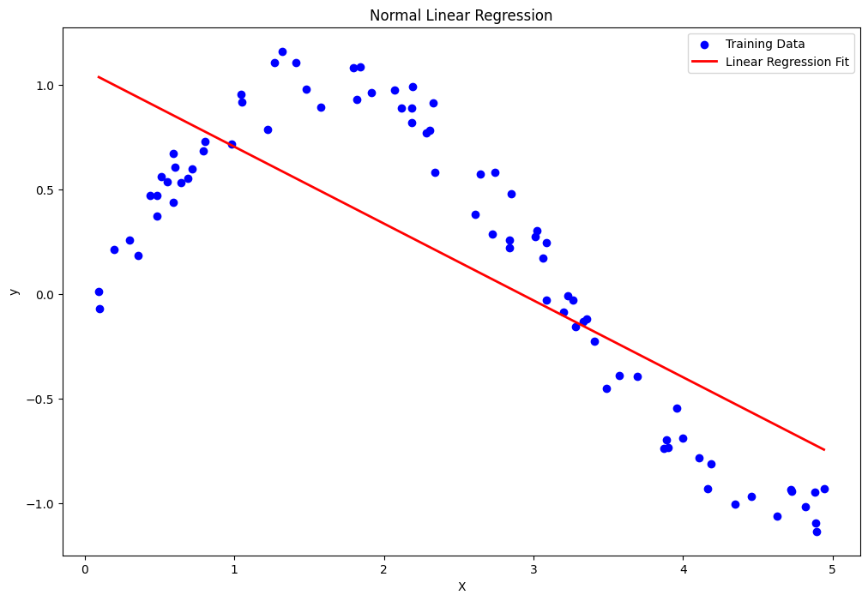

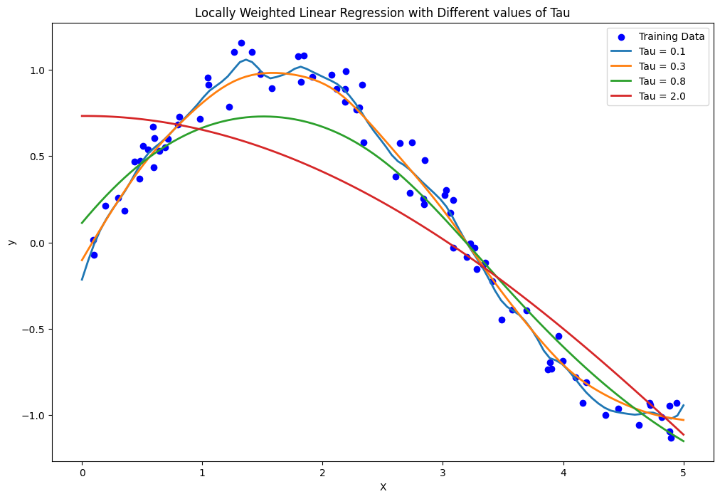

LAB ASSIGNMENT 5

|  |  |  |  |
| --- | --- | --- | --- |
| **Name:** | Harsh Shah | **Roll No.:** | 21BCP359 |
| **Division:** | 6 | **Batch:** | G11 |
| **Aim:** | For a given set of training data examples stored in a .CSV file, implement and demonstrate various feature selection algorithms and compare the performance of the  algorithms. | | |

**Objective**

The objective of this lab assignment is to implement and demonstrate various feature selection algorithms on a given training dataset stored in a .CSV file. The goal is to evaluate the effectiveness of these algorithms in terms of improving model accuracy and reducing dimensionality.

**Code**

import pandas as pd

import numpy as np

from sklearn.model_selection import KFold, cross_val_score

from sklearn.linear_model import LogisticRegression

from sklearn.model_selection import train_test_split

columns = ["Pregnancies", "GLucose", "BloodPressure", "Skin Thickness", "Insulin", "BMI", "DiabetesPedigreeFunction", "Age", "Outcome"]

dataset = pd.read_csv('./master_pima-indians-diabetes.csv')

dataset.head()

array = dataset.values

X = array[:, 0:8]

y = array[:, 8]

X_train, X_test, y_train, y_test = train_test_split(X, y, *test_size*=0.3, *random_state*=42)

**Univariate Analysis**

from sklearn.feature_selection import SelectKBest

from sklearn.feature_selection import chi2

test = SelectKBest(*score_func*=chi2, *k*=4)

fit = test.fit(X, y)

np.set_printoptions(*precision*=3)

features = fit.transform(X)

print("Scores: ")

print(fit.scores_)

print("Features: ")

print(features[0:5, :])



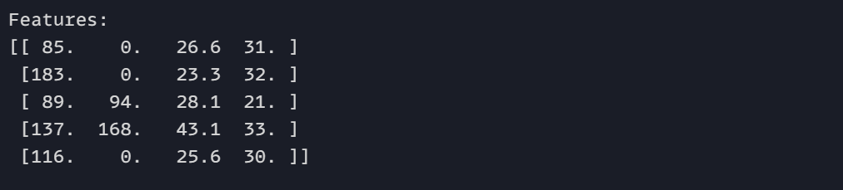

**Recursive Feature Elimination**

from sklearn.feature_selection import RFE

array = dataset.values

X = array[:, 0:8]

y = array[:, 8]

model = LogisticRegression()

rfe = RFE(model, *n_features_to_select*=4)

fit = rfe.fit(X,y)

print("Num Features: %d" % fit.n_features_)

print("Selected Features: %s" % fit.support_)

print("Feature Ranking: %s" % fit.ranking_)

reduced_dataset = dataset.iloc[:, :8].loc[:, fit.support_]

reduced_dataset.head()

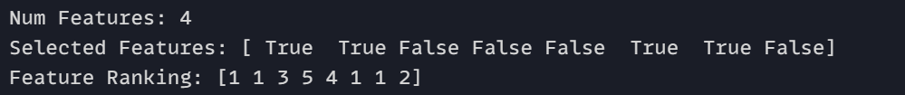



**Lasso - L1 Regularization**

from sklearn.linear_model import Lasso

from sklearn.preprocessing import StandardScaler

from sklearn.model_selection import train_test_split

scaler = StandardScaler()

X_scaled = scaler.fit_transform(X)

lasso = Lasso(*alpha*=0.05)

lasso.fit(X_train, y_train)

lasso_coefficients = lasso.coef_

selected_features = [feature for feature, coef in zip(columns, lasso_coefficients) if coef != 0]

print("Selected Features:", selected_features)



**Random Forest**

from sklearn.ensemble import RandomForestClassifier

from sklearn.model_selection import train_test_split

rf_model = RandomForestClassifier(*n_estimators*=100, *random_state*=42)

rf_model.fit(X_train, y_train)

rf_importances = rf_model.feature_importances_

sorted_indices = rf_importances.argsort()[::-1]

selected_features_rf = np.array(columns)[sorted_indices]

print("Feature Importances (Random Forest):")

for feature, importance in zip(selected_features_rf, rf_importances[sorted_indices]):

    print(*f*"{feature}: {importance*:.4f*}")

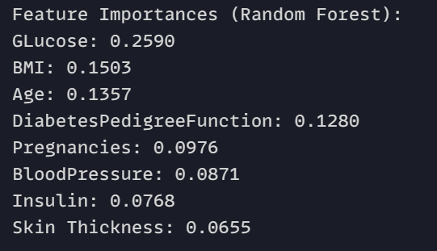

**XGBoost**

import xgboost as xgb

xgb_model = xgb.XGBClassifier(*use_label_encoder*=False, *eval_metric*='logloss')

xgb_model.fit(X_train, y_train)

xgb_importances = xgb_model.feature_importances_

sorted_indices = xgb_importances.argsort()[::-1]

selected_features_xgb = np.array(columns)[sorted_indices]

print("Feature Importances (XGBoost):")

for feature, importance in zip(selected_features_xgb, xgb_importances[sorted_indices]):

    print(*f*"{feature}: {importance*:.4f*}")

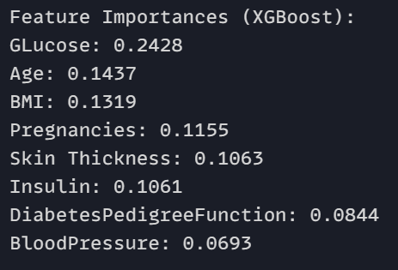

**Comparing Random Forest with and without feature selection**

import xgboost as xgb

import pandas as pd

import numpy as np

from sklearn.model_selection import train_test_split

from sklearn.metrics import accuracy_score, f1_score, precision_score, recall_score

from sklearn.ensemble import RandomForestClassifier

dataset = pd.read_csv('./master_pima-indians-diabetes.csv')

X = dataset.iloc[:, :-1]

y = dataset.iloc[:, -1]

X_train, X_test, y_train, y_test = train_test_split(X, y, *test_size*=0.3, *random_state*=42)

*# Step 1: Train XGBoost on the original dataset*

xgb_model_original = xgb.XGBClassifier(*use_label_encoder*=False, *eval_metric*='logloss')

xgb_model_original.fit(X_train, y_train)

y_pred_original = xgb_model_original.predict(X_test)

accuracy_original = accuracy_score(y_test, y_pred_original)

f1_original = f1_score(y_test, y_pred_original)

precision_original = precision_score(y_test, y_pred_original)

recall_original = recall_score(y_test, y_pred_original)

*# Step 2: Feature selection using Random Forest*

rf_model = RandomForestClassifier(*n_estimators*=100, *random_state*=42)

rf_model.fit(X_train, y_train)

rf_importances = rf_model.feature_importances_

sorted_indices = rf_importances.argsort()[::-1]

selected_features_rf = np.array(X.columns)[sorted_indices]

top_n = 5

X_train_selected = X_train[selected_features_rf[:top_n]]

X_test_selected = X_test[selected_features_rf[:top_n]]

*# Step 3: Train XGBoost on the reduced dataset (with feature selection)*

xgb_model_selected = xgb.XGBClassifier(*use_label_encoder*=False, *eval_metric*='logloss')

xgb_model_selected.fit(X_train_selected, y_train)

y_pred_selected = xgb_model_selected.predict(X_test_selected)

accuracy_selected = accuracy_score(y_test, y_pred_selected)

f1_selected = f1_score(y_test, y_pred_selected)

precision_selected = precision_score(y_test, y_pred_selected)

recall_selected = recall_score(y_test, y_pred_selected)

print("Performance on Original Dataset:")

print(*f*"Accuracy: {accuracy_original*:.4f*}, F1-Score: {f1_original*:.4f*}, Precision: {precision_original*:.4f*}, Recall: {recall_original*:.4f*}")

print("\nPerformance on Reduced Dataset (With Feature Selection):")

print(*f*"Accuracy: {accuracy_selected*:.4f*}, F1-Score: {f1_selected*:.4f*}, Precision: {precision_selected*:.4f*}, Recall: {recall_selected*:.4f*}")

**Output - Visualisation**





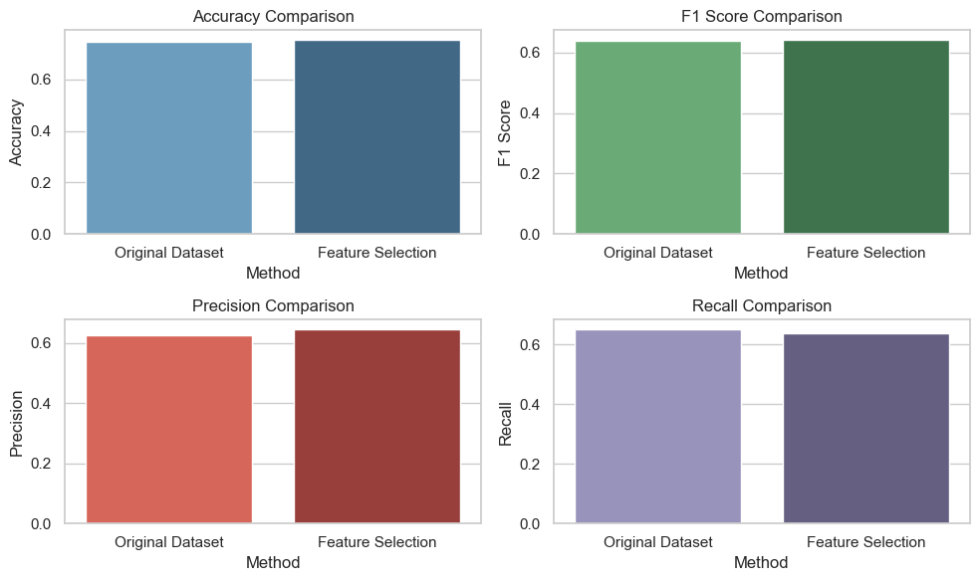

LAB ASSIGNMENT 6

|  |  |  |  |
| --- | --- | --- | --- |
| **Name:** | Harsh Shah | **Roll No.:** | 21BCP359 |
| **Division:** | 6 | **Batch:** | G11 |
| **Aim:** | Apply Different Machine Learning Approaches for the Classification Task. Compare the Performance of Different ML Approaches in Terms of Accuracy, Precision, and Recall. | | |

**Objective**

The objective of this lab assignment is to apply various Machine Learning (ML) approaches to a classification task and compare their performance in terms of accuracy, precision, and recall. You will gain hands-on experience in implementing and evaluating different ML algorithms, understanding their strengths and weaknesses, and interpreting their results.

**Code**

import pandas as pd

from sklearn.model_selection import train_test_split

from sklearn.preprocessing import LabelEncoder

from sklearn.metrics import accuracy_score, precision_score, recall_score

from sklearn.linear_model import LogisticRegression

from sklearn.tree import DecisionTreeClassifier

from sklearn.ensemble import RandomForestClassifier

from sklearn.neighbors import KNeighborsClassifier

from sklearn.preprocessing import StandardScaler

from sklearn.svm import SVC

import matplotlib.pyplot as plt

import seaborn as sns

data = pd.read_csv("data.csv")

data.head()

data_cleaned = data.drop(*columns*=["id", "Unnamed: 32"])

label_encoder = LabelEncoder()

data_cleaned["diagnosis"] = label_encoder.fit_transform(data_cleaned["diagnosis"])

X = data_cleaned.drop(*columns*=["diagnosis"])

y = data_cleaned["diagnosis"]

X_train, X_test, y_train, y_test = train_test_split(

    X, y, *test_size*=0.2, *random_state*=42, *stratify*=y

)

scaler = StandardScaler()

X_train_scaled = scaler.fit_transform(X_train)

X_test_scaled = scaler.transform(X_test)

models = {

    "Logistic Regression": LogisticRegression(*max_iter*=10000),

    "Decision Tree": DecisionTreeClassifier(),

    "Random Forest": RandomForestClassifier(),

    "K-Nearest Neighbors": KNeighborsClassifier(),

    "Support Vector Machine": SVC(),

}

metrics = {"Model": [], "Accuracy": [], "Precision": [], "Recall": []}

for model_name, model in models.items():

    if model_name in [

        "Logistic Regression",

        "K-Nearest Neighbors",

        "Support Vector Machine",

    ]:

        model.fit(X_train_scaled, y_train)

        y_pred = model.predict(X_test_scaled)

    else:

        model.fit(X_train, y_train)

        y_pred = model.predict(X_test)

    metrics["Model"].append(model_name)

    metrics["Accuracy"].append(accuracy_score(y_test, y_pred))

    metrics["Precision"].append(precision_score(y_test, y_pred))

    metrics["Recall"].append(recall_score(y_test, y_pred))

metrics_df = pd.DataFrame(metrics)

print(metrics_df)

plt.figure(*figsize*=(10, 6))

sns.barplot(*x*="Model", *y*="Accuracy", *data*=metrics_df)

plt.title("Accuracy Comparison")

plt.xticks(*rotation*=45)

plt.show()

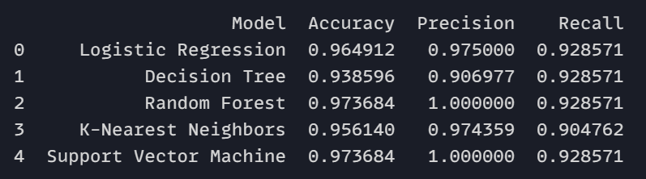

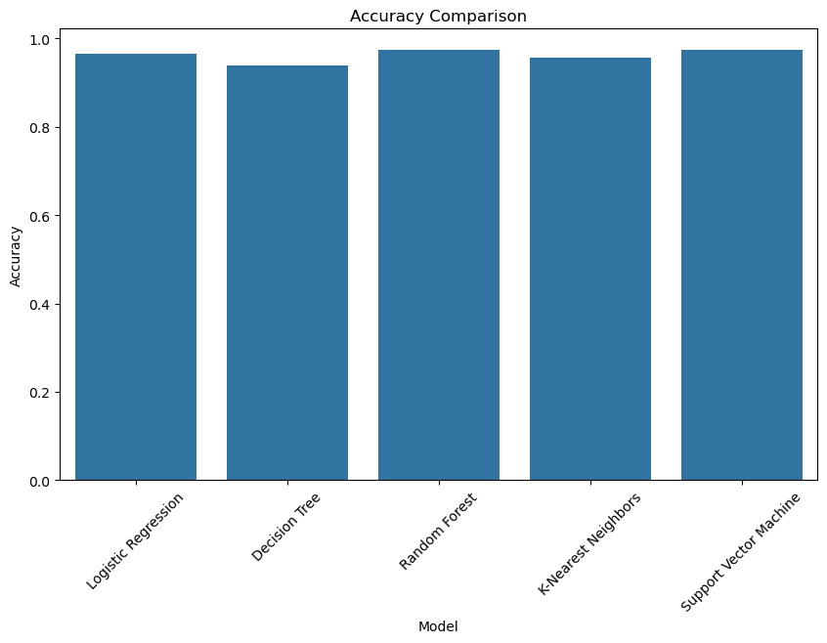

plt.figure(*figsize*=(10, 6))

sns.barplot(*x*="Model", *y*="Precision", *data*=metrics_df)

plt.title("Precision Comparison")

plt.xticks(*rotation*=45)

plt.show()

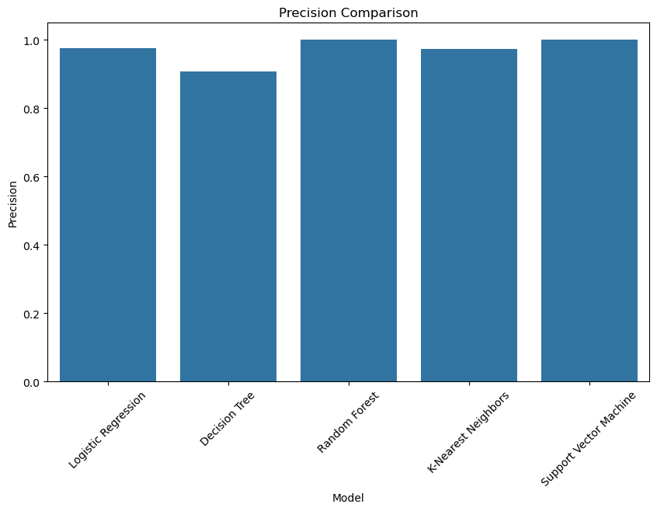

plt.figure(*figsize*=(10, 6))

sns.barplot(*x*="Model", *y*="Recall", *data*=metrics_df)

plt.title("Recall Comparison")

plt.xticks(*rotation*=45)

plt.show()

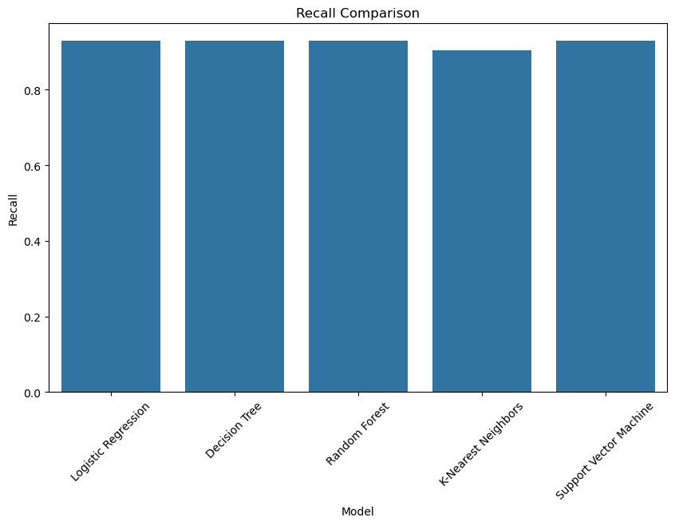

from sklearn.model_selection import GridSearchCV

param_grid = {

    "n_estimators": [50, 100, 150],

    "max_depth": [None, 10, 20, 30],

    "min_samples_split": [2, 5, 10],

}

grid_search = GridSearchCV(

    RandomForestClassifier(), param_grid, *cv*=5, *scoring*="accuracy"

)

grid_search.fit(X_train, y_train)

print("Best parameters for Random Forest:", grid_search.best_params_)

best_rf = grid_search.best_estimator_

y_pred_best_rf = best_rf.predict(X_test)

accuracy_best_rf = accuracy_score(y_test, y_pred_best_rf)

precision_best_rf = precision_score(y_test, y_pred_best_rf)

recall_best_rf = recall_score(y_test, y_pred_best_rf)

print(

*f*"Best Random Forest - Accuracy: {accuracy_best_rf}, Precision: {precision_best_rf}, Recall: {recall_best_rf}"

)

**Output**



LAB ASSIGNMENT 7

|  |  |  |  |
| --- | --- | --- | --- |
| **Name:** | Harsh Shah | **Roll No.:** | 21BCP359 |
| **Division:** | 6 | **Batch:** | G11 |
| **Aim:** | Train a Machine Learning Classifier on an Imbalanced Dataset. Then Balance the Dataset Using Oversampling Techniques. Compare the Model Performance Before and After Oversampling. | | |

**Objective**

In this lab assignment, you will work with an imbalanced dataset and train a machine learning classifier on it. Afterward, you will apply oversampling techniques to balance the dataset and compare the model's performance before and after oversampling. The goal is to observe how oversampling affects the classifier's performance when dealing with imbalanced data.

**Dataset:** <https://raw.githubusercontent.com/jbrownlee/Datasets/master/pima-indians-diabetes.csv>

**Code**

import pandas as pd

import numpy as np

from sklearn.model_selection import train_test_split

from sklearn.preprocessing import StandardScaler

from sklearn.ensemble import RandomForestClassifier

from sklearn.metrics import classification_report, confusion_matrix

from imblearn.over_sampling import SMOTE

url = "https://raw.githubusercontent.com/jbrownlee/Datasets/master/pima-indians-diabetes.csv"

column_names = [

    "Pregnancies",

    "Glucose",

    "BloodPressure",

    "SkinThickness",

    "Insulin",

    "BMI",

    "DiabetesPedigreeFunction",

    "Age",

    "Outcome",

]

data = pd.read_csv(url, *names*=column_names)

print("\nClass Distribution:\n", data["Outcome"].value_counts())

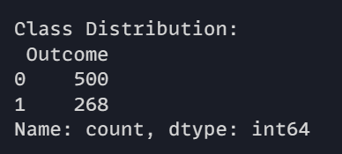

X = data.drop("Outcome", *axis*=1)

y = data["Outcome"]

X_train, X_test, y_train, y_test = train_test_split(

    X, y, *test_size*=0.2, *random_state*=42, *stratify*=y

)

scaler = StandardScaler()

X_train = scaler.fit_transform(X_train)

X_test = scaler.transform(X_test)

clf = RandomForestClassifier(*random_state*=42)

clf.fit(X_train, y_train)

y_pred = clf.predict(X_test)

print("\nBefore Oversampling:")

print(confusion_matrix(y_test, y_pred))

print(classification_report(y_test, y_pred))

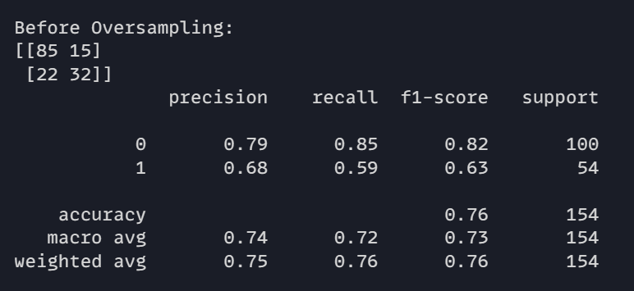

smote = SMOTE(*random_state*=42)

X_train_smote, y_train_smote = smote.fit_resample(X_train, y_train)

clf_smote = RandomForestClassifier(*random_state*=42)

clf_smote.fit(X_train_smote, y_train_smote)

y_pred_smote = clf_smote.predict(X_test)

print("\nAfter Oversampling (SMOTE):")

print(confusion_matrix(y_test, y_pred_smote))

print(classification_report(y_test, y_pred_smote))

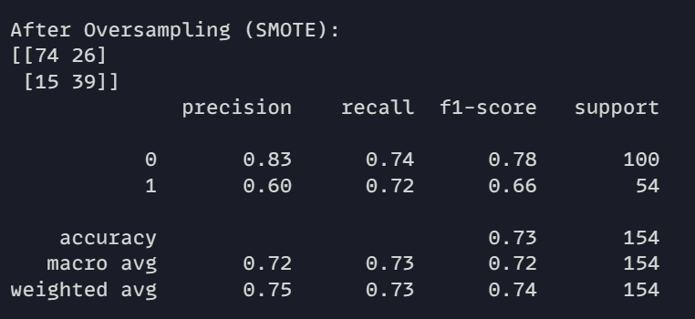

from sklearn.metrics import accuracy_score, precision_score, recall_score, f1_score

*def* evaluate_model(*y_true*, *y_pred*):

    accuracy = accuracy_score(y_true, y_pred)

    precision = precision_score(y_true, y_pred)

    recall = recall_score(y_true, y_pred)

    f1 = f1_score(y_true, y_pred)

    return {

        "accuracy": accuracy,

        "precision": precision,

        "recall": recall,

        "f1_score": f1,

    }

y_pred = clf.predict(X_test)

results_before = evaluate_model(y_test, y_pred)

y_pred_smote = clf_smote.predict(X_test)

results_after = evaluate_model(y_test, y_pred_smote)

print("\nPerformance Metrics Comparison:")

print(*f*"{'Metric'*:<15*}{'Before Oversampling'*:<25*}{'After Oversampling'*:<25*}")

for metric in results_before.keys():

    print(

*f*"{metric.capitalize()*:<15*}{results_before[metric]*:<25.4f*}{results_after[metric]*:<25.4f*}"

    )

**Output**

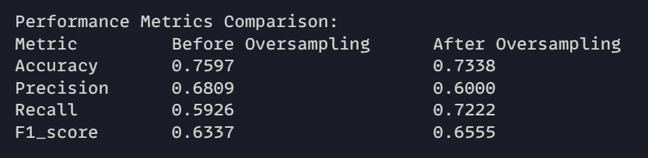

LAB ASSIGNMENT 8

|  |  |  |  |
| --- | --- | --- | --- |
| **Name:** | Harsh Shah | **Roll No.:** | 21BCP359 |
| **Division:** | 6 | **Batch:** | G11 |
| **Aim:** | Apply Different Feature Selection Approaches for the Classification/Regression Task. Compare the Performance of Different Feature Selection Approaches. | | |

**Objective**

The objective of this lab assignment is to explore various feature selection techniques for classification and regression tasks.

**Dataset:** Use the UCI Iris dataset for the classification task and the Boston Housing dataset for the regression task.

**Code**

import numpy as np

import pandas as pd

from scipy.stats import chi2_contingency

*class* SelectKBest:

*def* __init__(*self*, *score_func*, *k*='all'):

*self*.score_func = score_func

*self*.k = k

*self*.scores_ = None

*self*.selected_features_ = None

*def* fit(*self*, *X*, *y*):

        y = y.ravel()

*self*.scores_ = np.array([*self*.score_func(X.iloc[:, i], y) for i in range(X.shape[1])])

        if *self*.k == 'all':

*self*.k = X.shape[1]

*self*.selected_indices_ = np.argsort(*self*.scores_)[-*self*.k:]

*self*.selected_features_ = X.columns[*self*.selected_indices_]

        return *self*

*def* transform(*self*, *X*):

        return X.iloc[:, *self*.selected_indices_]

*def* fit_transform(*self*, *X*, *y*):

        return *self*.fit(X, y).transform(X)

*def* chi2_score(*x*, *y*):

    contingency_table = pd.crosstab(x, y)

    chi2_stat, _, _, _ = chi2_contingency(contingency_table)

    return chi2_stat

from sklearn.base import BaseEstimator, RegressorMixin

from sklearn.utils import check_X_y, check_array

*class* RFE:

*def* __init__(*self*, *estimator*, *n_features_to_select*=1):

*self*.estimator = estimator

*self*.n_features_to_select = n_features_to_select

*self*.support_ = None

*self*.ranking_ = None

*def* fit(*self*, *X*, *y*):

        X, y = check_X_y(X, y)

        n_features = X.shape[1]

*self*.ranking_ = np.zeros(n_features)

        while n_features > *self*.n_features_to_select:

*self*.estimator.fit(X, y)

            importances = *self*.estimator.feature_importances_ if hasattr(*self*.estimator, 'feature_importances_') else np.abs(*self*.estimator.coef_)

            worst_feature = np.argmin(importances)

*self*.ranking_[worst_feature] += 1

            X = np.delete(X, worst_feature, *axis*=1)

            n_features -= 1

*self*.support_ = np.where(*self*.ranking_ == 0)[0]

        return *self*

*def* transform(*self*, *X*):

        return X.iloc[:, *self*.support_]

*def* fit_transform(*self*, *X*, *y*):

        return *self*.fit(X, y).transform(X)

from sklearn.linear_model import Lasso

from sklearn.utils import check_X_y

*class* L1FeatureSelector:

*def* __init__(*self*, *alpha*=1.0):

*self*.alpha = alpha

*self*.model = Lasso(*alpha*=*self*.alpha)

*self*.selected_features_ = None

*def* fit(*self*, *X*, *y*):

        X, y = check_X_y(X, y)

*self*.model.fit(X, y)

*self*.selected_features_ = np.where(*self*.model.coef_ != 0)[0]

        return *self*

*def* transform(*self*, *X*):

        return X.iloc[:, *self*.selected_features_]

*def* fit_transform(*self*, *X*, *y*):

        return *self*.fit(X, y).transform(X)

from sklearn.ensemble import RandomForestClassifier

from sklearn.utils import check_X_y

*class* TreeBasedFeatureSelector:

*def* __init__(*self*, *n_estimators*=100):

*self*.n_estimators = n_estimators

*self*.model = RandomForestClassifier(*n_estimators*=*self*.n_estimators)

*self*.selected_features_ = None

*def* fit(*self*, *X*, *y*):

        X, y = check_X_y(X, y)

*self*.model.fit(X, y)

        importances = *self*.model.feature_importances_

*self*.selected_features_ = np.where(importances > 0)[0]

        return *self*

*def* transform(*self*, *X*):

        return X.iloc[:, *self*.selected_features_]

*def* fit_transform(*self*, *X*, *y*):

        return *self*.fit(X, y).transform(X)

*# Sample Data*

import pandas as pd

from sklearn.datasets import load_iris

data = load_iris()

X = pd.DataFrame(data.data, *columns*=data.feature_names)

y = data.target

*# Univariate Feature Selection*

selector_kbest = SelectKBest(*score_func*=chi2_score, *k*=2)

X_kbest = selector_kbest.fit_transform(X, y)

print("Selected Features (KBest):", selector_kbest.selected_features_)

*# Recursive Feature Elimination*

rfe_selector = RFE(*estimator*=RandomForestClassifier(), *n_features_to_select*=2)

X_rfe = rfe_selector.fit_transform(X, y)

print("Selected Features (RFE):", X.columns[rfe_selector.support_])

*# L1-Based Feature Selection*

l1_selector = L1FeatureSelector(*alpha*=0.1)

X_l1 = l1_selector.fit_transform(X, y)

print("Selected Features (L1):", X.columns[l1_selector.selected_features_])

*# Tree-Based Feature Selection*

tree_selector = TreeBasedFeatureSelector()

X_tree = tree_selector.fit_transform(X, y)

print("Selected Features (Tree-Based):", X.columns[tree_selector.selected_features_])

**Output**

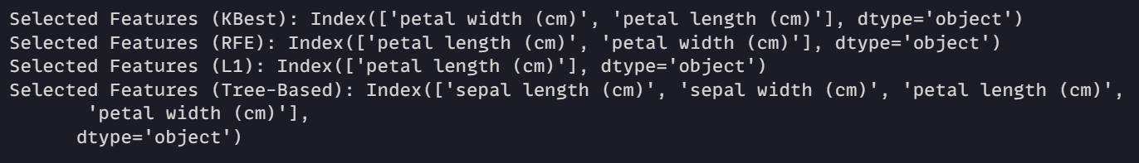

LAB ASSIGNMENT 9

|  |  |  |  |
| --- | --- | --- | --- |
| **Name:** | Harsh Shah | **Roll No.:** | 21BCP359 |
| **Division:** | 6 | **Batch:** | G11 |
| **Aim:** | Write a Program to Demonstrate the Working of the Decision Tree-Based CART Algorithm. Build the Decision Tree and Classify a New Sample Using a Suitable Dataset. Compare the Performance with That of ID3, C4.5, and CART in Terms of Accuracy, Recall, Precision, and Sensitivity. | | |

**Objective**

The objective of this lab assignment is to implement the Decision Tree-based Classification and Regression Trees (CART) algorithm and compare its performance with other decision tree algorithms, namely ID3 and C4.5, in terms of accuracy, recall, precision, and sensitivity. The assignment includes building decision trees, classifying new samples, and evaluating the models using a suitable dataset.

**Code**

import numpy as np

import pandas as pd

*class* TreeNode:

*def* __init__(*self*, *feature_index*=None, *threshold*=None, *left*=None, *right*=None, *value*=None):

*self*.feature_index = feature_index

*self*.threshold = threshold

*self*.left = left

*self*.right = right

*self*.value = value

*class* CART:

*def* fit(*self*, *X*, *y*):

*self*.root = *self*._grow_tree(X, y)

*def* _grow_tree(*self*, *X*, *y*):

        if len(*set*(y)) == 1:

            return TreeNode(*value*=y[0])

        best_gain = -*float*('inf')

        best_criteria = None

        best_sets = None

        n_samples, n_features = X.shape

        for feature_index in range(n_features):

            thresholds = np.unique(X[:, feature_index])

            for threshold in thresholds:

                left_indices = X[:, feature_index] <= threshold

                right_indices = X[:, feature_index] > threshold

                if len(y[left_indices]) == 0 or len(y[right_indices]) == 0:

                    continue

                gain = *self*._gini_gain(y, left_indices, right_indices)

                if gain > best_gain:

                    best_gain = gain

                    best_criteria = (feature_index, threshold)

                    best_sets = (left_indices, right_indices)

        if best_gain == -*float*('inf'):

            return TreeNode(*value*=np.bincount(y).argmax())

        left_node = *self*._grow_tree(X[best_sets[0]], y[best_sets[0]])

        right_node = *self*._grow_tree(X[best_sets[1]], y[best_sets[1]])

        return TreeNode(*feature_index*=best_criteria[0], *threshold*=best_criteria[1], *left*=left_node, *right*=right_node)

*def* _gini_gain(*self*, *y*, *left_indices*, *right_indices*):

        parent_impurity = *self*._gini_impurity(y)

        left_impurity = *self*._gini_impurity(y[left_indices])

        right_impurity = *self*._gini_impurity(y[right_indices])

        n = len(y)

        n_left = len(y[left_indices])

        n_right = len(y[right_indices])

        weighted_child_impurity = (n_left / n) * left_impurity + (n_right / n) * right_impurity

        return parent_impurity - weighted_child_impurity

*def* _gini_impurity(*self*, *y*):

        class_counts = np.bincount(y)

        return 1.0 - np.sum((class_counts / len(y)) ** 2)

*def* predict(*self*, *X*):

        return [*self*._predict(inputs) for inputs in X]

*def* _predict(*self*, *inputs*):

        node = *self*.root

        while node.value is None:

            if inputs[node.feature_index] <= node.threshold:

                node = node.left

            else:

                node = node.right

        return node.value

from sklearn.tree import DecisionTreeClassifier

*def* build_id3(*X_train*, *y_train*):

    model = DecisionTreeClassifier(*criterion*='entropy')  *# ID3 uses entropy*

    model.fit(X_train, y_train)

    return model

*def* build_c45(*X_train*, *y_train*):

    model = DecisionTreeClassifier(*criterion*='gini')  *# C4.5 uses Gini impurity*

    model.fit(X_train, y_train)

    return model

from sklearn.metrics import accuracy_score, recall_score, precision_score, confusion_matrix

*def* evaluate_model(*model*, *X_test*, *y_test*):

    y_pred = model.predict(X_test) if hasattr(model, 'predict') else model.predict(X_test)

    accuracy = accuracy_score(y_test, y_pred)

    recall = recall_score(y_test, y_pred)

    precision = precision_score(y_test, y_pred)

*# Confusion matrix*

    tn, fp, fn, tp = confusion_matrix(y_test, y_pred).ravel()

    sensitivity = tp / (tp + fn) if (tp + fn) > 0 else 0  *# Avoid division by zero*

    return accuracy, recall, precision, sensitivity

from sklearn.model_selection import train_test_split

*def* load_titanic_dataset():

    url = "https://raw.githubusercontent.com/datasciencedojo/datasets/master/titanic.csv"

    data = pd.read_csv(url)

*# Preprocess the data: drop rows with missing target and fill missing values*

    data = data.drop(*columns*=["Name", "Ticket", "Cabin"])  *# Drop non-feature columns*

    data['Embarked'] = data['Embarked'].fillna('S')  *# Fill missing Embarked*

    data['Age'] = data['Age'].fillna(data['Age'].median())  *# Fill missing Age with median*

    data['Fare'] = data['Fare'].fillna(data['Fare'].median())  *# Fill missing Fare with median*

*# Convert categorical variables to dummy variables*

    data = pd.get_dummies(data, *columns*=["Sex", "Embarked"], *drop_first*=True)

    X = data.drop("Survived", *axis*=1)  *# Features*

    y = data["Survived"]  *# Target labels*

    return train_test_split(X, y, *test_size*=0.2, *random_state*=42)

import matplotlib.pyplot as plt

from sklearn.tree import plot_tree

*def* compare_models():

    X_train, X_test, y_train, y_test = load_titanic_dataset()

*# Implement CART from scratch*

    cart_model = CART()

    cart_model.fit(X_train.to_numpy(), y_train.to_numpy())

*# Using scikit-learn for ID3 and C4.5*

    id3_model = build_id3(X_train, y_train)

    c45_model = build_c45(X_train, y_train)

*# Evaluate models*

    cart_metrics = evaluate_model(cart_model, X_test.to_numpy(), y_test.to_numpy())

    id3_metrics = evaluate_model(id3_model, X_test, y_test)

    c45_metrics = evaluate_model(c45_model, X_test, y_test)

*# Print comparison*

    print("CART Metrics (Accuracy, Recall, Precision, Sensitivity):", cart_metrics)

    print("ID3 Metrics (Accuracy, Recall, Precision, Sensitivity):", id3_metrics)

    print("C4.5 Metrics (Accuracy, Recall, Precision, Sensitivity):", c45_metrics)

*# Visualize the CART tree*

    plt.figure(*figsize*=(12, 8))

    plot_tree(id3_model, *filled*=True, *feature_names*=X_train.columns, *class_names*=['Not Survived', 'Survived'])

    plt.title("ID3 Decision Tree")

    plt.show()

    plt.figure(*figsize*=(12, 8))

    plot_tree(c45_model, *filled*=True, *feature_names*=X_train.columns, *class_names*=['Not Survived', 'Survived'])

    plt.title("C4.5 Decision Tree")

    plt.show()

*# Run the comparison*

compare_models()

**Output**



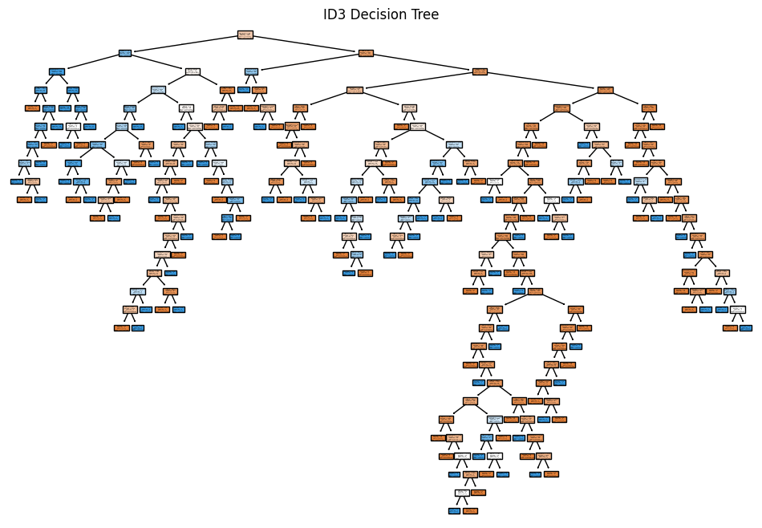

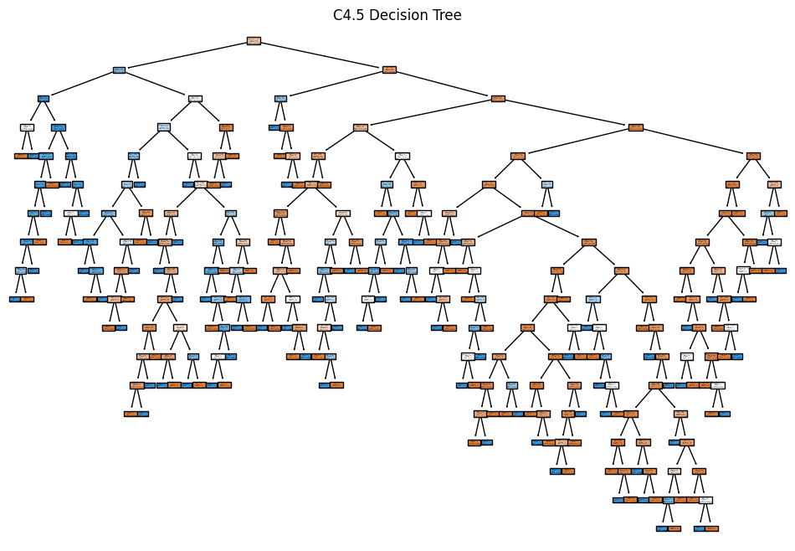

LAB ASSIGNMENT 10

|  |  |  |  |
| --- | --- | --- | --- |
| **Name:** | Harsh Shah | **Roll No.:** | 21BCP359 |
| **Division:** | 6 | **Batch:** | G11 |
| **Aim:** | Implement Dimensionality reduction using Principal Component Analysis (PCA) method. | | |

**Objective**

The objective of this lab assignment is to implement dimensionality reduction using Principal Component Analysis (PCA) and gain hands-on experience in reducing the dimensionality of a dataset while preserving its essential information.

**Code**

import numpy as np

import matplotlib.pyplot as plt

from sklearn.datasets import make_blobs

X, y = make_blobs(*n_samples*=300, *centers*=4, *random_state*=42, *cluster_std*=1.0)

plt.scatter(X[:, 0], X[:, 1], *s*=50, *c*='gray')

plt.title('Generated Dataset')

plt.show()

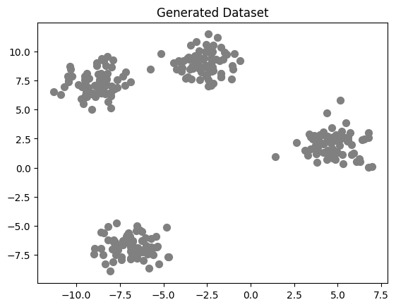

*class* KMeans:

*def* __init__(*self*, *k*, *max_iters*=100):

*self*.k = k

*self*.max_iters = max_iters

*self*.centroids = None

*def* initialize_centroids(*self*, *X*):

        np.random.seed(42)

        random_indices = np.random.permutation(X.shape[0])

        centroids = X[random_indices[:*self*.k]]

        return centroids

*def* assign_clusters(*self*, *X*, *centroids*):

        distances = np.linalg.norm(X[:, np.newaxis] - centroids, *axis*=2)

        return np.argmin(distances, *axis*=1)

*def* update_centroids(*self*, *X*, *labels*):

        new_centroids = np.array([X[labels == i].mean(*axis*=0) for i in range(*self*.k)])

        return new_centroids

*def* fit(*self*, *X*):

*self*.centroids = *self*.initialize_centroids(X)

        for i in range(*self*.max_iters):

            labels = *self*.assign_clusters(X, *self*.centroids)

            new_centroids = *self*.update_centroids(X, labels)

            if np.all(*self*.centroids == new_centroids):

                break

*self*.centroids = new_centroids

        return *self*.centroids, labels

*def* inertia(*self*, *X*, *labels*):

        return np.sum((X - *self*.centroids[labels]) ** 2)

kmeans = KMeans(*k*=4)

initial_centroids = kmeans.initialize_centroids(X)

centroids, labels = kmeans.fit(X)

plt.scatter(X[:, 0], X[:, 1], *s*=50, *c*='gray', *label*='Data Points')

plt.scatter(initial_centroids[:, 0], initial_centroids[:, 1], *s*=200, *c*='red', *marker*='X', *label*='Initial Centroids')

plt.title('Initial Random Centroids')

plt.legend()

plt.show()

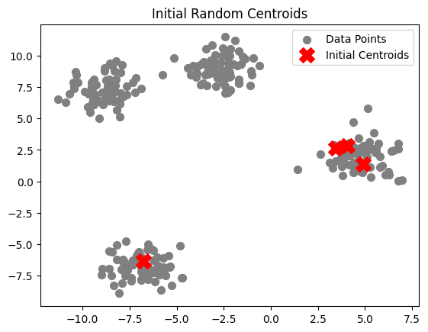

plt.scatter(X[:, 0], X[:, 1], *c*=labels, *s*=50, *cmap*='viridis', *label*='Data Points')

plt.scatter(centroids[:, 0], centroids[:, 1], *s*=200, *c*='blue', *marker*='X', *label*='Final Centroids')

plt.title('K-Means Clustering with Final Centroids')

plt.legend()

plt.show()

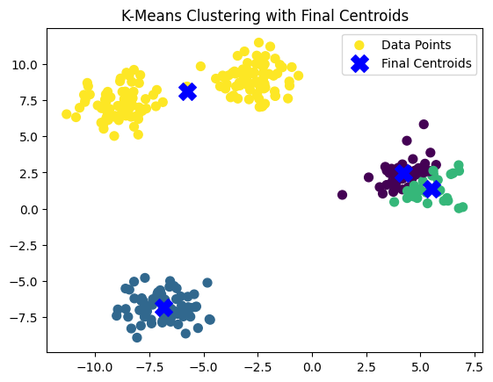

inertia_values = []

K_values = range(1, 11)

for k in K_values:

    kmeans = KMeans(*k*=k)

    centroids, labels = kmeans.fit(X)

    inertia = kmeans.inertia(X, labels)

    inertia_values.append(inertia)

plt.plot(K_values, inertia_values, *marker*='o')

plt.title('Elbow Method for Optimal K')

plt.xlabel('Number of clusters (K)')

plt.ylabel('Inertia (Sum of Squared Distances)')

plt.xticks(K_values)

plt.grid()

plt.show()

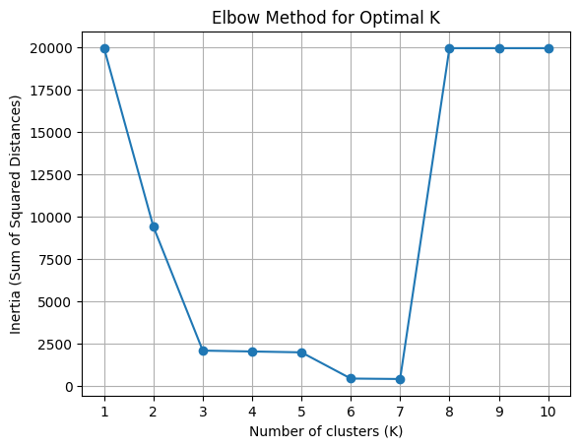

for k, inertia in zip(K_values, inertia_values):

    print(*f*"K = {k}, Inertia = {inertia*:.2f*}")

optimal_k = K_values[np.argmin(inertia_values)]

print(*f*"The optimal K is: {optimal_k}")

kmeans_optimal = KMeans(*k*=optimal_k)

centroids_optimal, labels_optimal = kmeans_optimal.fit(X)

plt.scatter(X[:, 0], X[:, 1], *c*=labels_optimal, *s*=50, *cmap*='viridis', *label*='Data Points')

plt.scatter(centroids_optimal[:, 0], centroids_optimal[:, 1], *s*=200, *c*='blue', *marker*='X', *label*='Final Centroids')

plt.title(*f*'K-Means Clustering with Optimal K = {optimal_k}')

plt.legend()

plt.show()

**Output**

